**Experiment No: 01**

**Study the use of Nmap for different options to scan open ports, perform OS fingerprinting, do a ping scan.**

# Aim:

Download and install nmap. Use it with different options to scan openports, perform OS fingerprinting, do a ping scan, tcp port scan, etc.

# Objectives:

Objective of this module to learn nmap installation & use this to scandifferent ports.

# Theory:

Nmap is short for Network Mapper. It is an open-source security tool for network exploration, security scanning and auditing. However, Nmap command comes with lots of options that can make the utility more robust and difficult to follow for new users.

# To find the Open Port Details

Port Scanning Port scanning allows a hacker to determine what services are running on the systems that have been identified. If vulnerable or insecure services are discovered, the hacker may be able to exploit these to gain unauthorized access.

nmap <target host> nmap [www.youtube.com](http://www.youtube.com/)

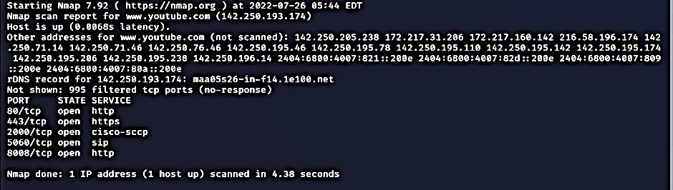

# To perform OS fingerprint scan [-F –O]

Nmap OS fingerprinting works by sending up to 16 TCP, UDP, and ICMP probes to known open and closed ports of the target machine. These probes are specially designed to exploit various ambiguities in the standard protocol RFCs. Then Nmap listens for responses. Dozens of attributes in those responses are analysed and combined to generate a fingerprint.

nmap -F -O <target host> nmap -F -O 192.168.53.126

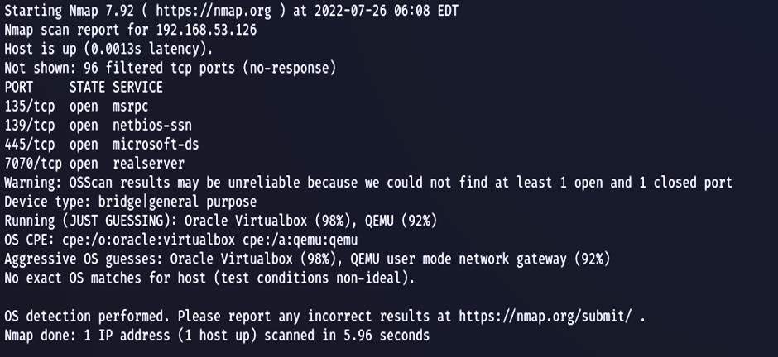

# To perform Ping scan [-sP]

This scan type lists the hosts within the specified range that responded to a ping. It allows you to detect which computers are online, rather than which ports are open. Four methods exist within Nmap for ping sweeping.

nmap –sP <target host> nmap –sP 142.250.193.174

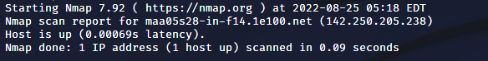

# To perform Version scanning [-sV]

Nmap has a database of more than 2000 services and associated ports for example– SSH (port 22) and HTTP (port 80). So, while doing network inventories if you want to know which

versions are running, you can use the Nmap version detection (-sV) command. Knowing the exact version number can be really helpful while finding which exploits your server is vulnerable to.

nmap -sV <target host> nmap -sV [www.hotstar.com](http://www.hotstar.com/)

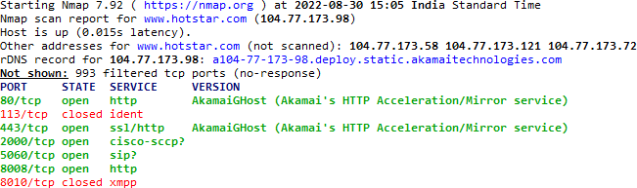

# To perform IP Protocol Scans [-sO]

The IP Protocol Scans attempt to determine the IP protocols supported on a target. Nmap sends a raw IP packet without any additional protocol header (see a good TCP/IP book for information about IP packets), to each protocol on the target machine. Receipt of an ICMP Protocol Unreachable message tells us the protocol is not in use, otherwise it is assumed open.

nmap -sO <target host> nmap -sO linux.org

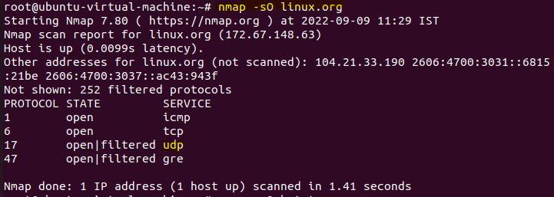

# To perform TCP Scan [-sT]

These scans are so called because UNIX sockets programming uses a system call

named connect() to begin a TCP connection to a remote site. If connect() succeeds, a connection was made. If it fails, the connection could not be made (the remote system is offline, the port is closed, or some other error occurred along the way). This allows a basic type of port scan, which attempts to connect to every port in turn, and notes whether or not the connection succeeded.

Once the scan is completed, ports to which a connection could be established are listed as *open*, the rest are said to be closed.

nmap -sT <target host>

nmap -sT mangaloreuniversity.ac.in

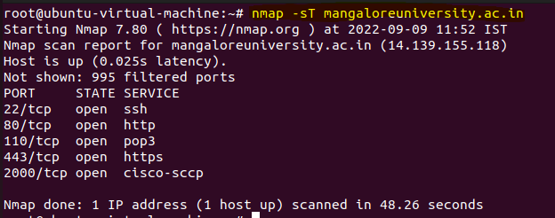

# To perform UDP Scan [-sU]

Scanning for open UDP ports is done with the -sU option. With this scan type, Nmap sends 0- byte UDP packets to each target port on the victim. Receipt of an ICMP Port Unreachable message signifies the port is closed, otherwise it is assumed open.One major problem with this technique is that, when a firewall blocks outgoing ICMP Port Unreachable messages, the port will appear open. These false-positives are hard to distinguish from real open ports.

nmap -sU <target host> nmap -sU hotstar.com

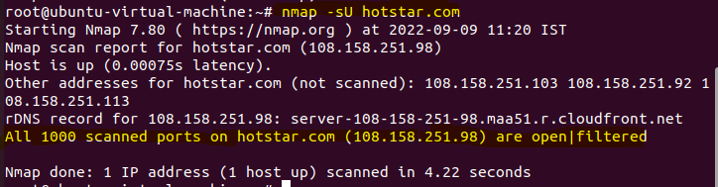

# Conclusion:

Using this tool, we have learned the various scanning methods for TCP, Protocol scanning, host scanning and basic idea of usage of nmap.

**Experiment No: 02**

**Setup Home Network and Computer Lab Setup using CISCO Packet Tracer**

# Home Network:

**Aim:**

Configure Of Home network Using cisco Packet tracer.

# Objectives:

The objectives for creating a home network using Cisco Packet Tracer include setting up a foundational network structure encompassing various devices, configuring routers with security measures and route management, establishing a secure wireless network with encryption and guest access, implementing Internet sharing through NAT, enabling port forwarding for specific services, creating Virtual LANs (VLANs) for segmentation, applying network security through access control measures, optimizing network performance using Quality of Service (QoS) settings, setting up remote access via VPN, monitoring network health using SNMP, ensuring redundancy and failover mechanisms, practicing IPv6 integration, honing network troubleshooting skills, integrating IoT devices, and creating comprehensive documentation for the network's layout and configurations.

# Theory:

Packet Tracer is a network simulation tool that allows us to create network topologies by building virtual networking devices. Packet Tracer is highly encouraged for network enthusiasts as it allows them to have keen in-depth knowledge of networking.

A home network implemented through Cisco Packet Tracer involves interconnecting various devices within a residence to facilitate seamless communication and resource sharing. This setup typically includes routers for routing data between devices and providing internet connectivity, switches for local device connections, and wireless access points for wireless connectivity. Configuration tasks encompass assigning unique IP addresses to devices, configuring subnet masks to define network boundaries, setting up DHCP to automate IP address allocation, and

implementing NAT to enable multiple devices to share a single public IP address. Security measures involve creating access control lists (ACLs) to control traffic flow, utilizing WPA2 encryption for secure wireless communication, and employing firewall rules to safeguard against unauthorized access. This simulated environment allows for practice in network design, configuration, and troubleshooting within a controlled context.

**Tools:** Router, PC, Laptop, Smartphone.

# Procedure:

### Step 1:

Open Packet Tracer and pick Home Router from Wireless Devices and place it on the workspace.

[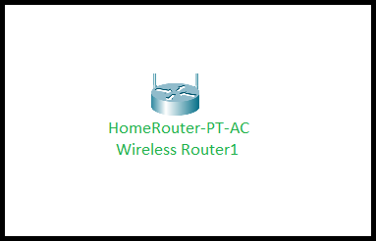](https://media.geeksforgeeks.org/wp-content/uploads/20200829180227/c1.PNG)

### Step 2:

Place Smartphone, PC, Laptop from End Devices on Workspace.

[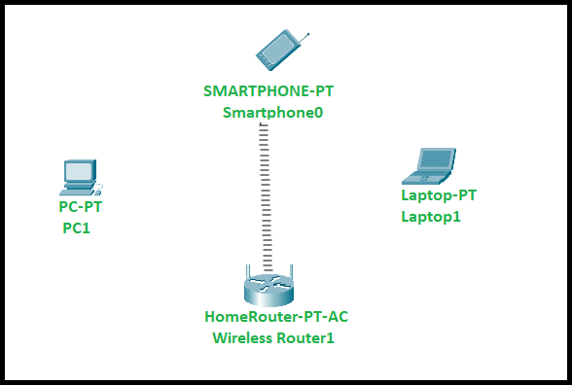](https://media.geeksforgeeks.org/wp-content/uploads/20200829184002/c2.PNG)

**Note:** that Smartphone automatically connects to the home router after placing it on the workspace...!!

### Step 3:

Connect the pc to the home router by using Copper Cross-Over wire available from connections by configuring pc to FastEthernet0 and Home Router to Gigabit Ethernet1.

[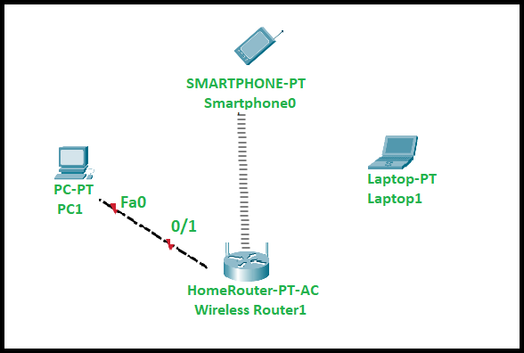](https://media.geeksforgeeks.org/wp-content/uploads/20200829184544/c3.PNG)

# Step 4:

To connect Laptop to Home Router we need to update a pin in the laptop’s configuration, to do this click on the laptop and turn of the laptop and find the pin WPC300N and place it in the laptop.

**Note:** To update the pin with WPC300N, the laptop must be turned off.

[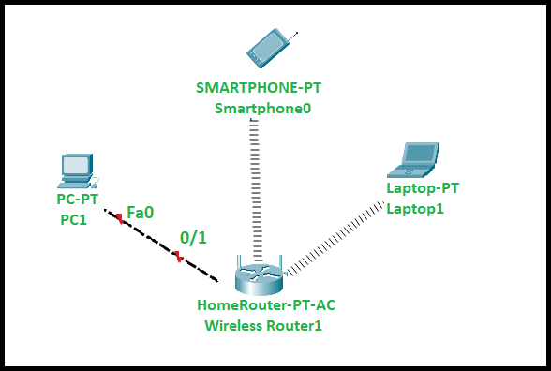](https://media.geeksforgeeks.org/wp-content/uploads/20200829184731/c4.PNG)

# Result:

The final result of building a home network using Cisco Packet Tracer is a functional ecosystem of interconnected devices, including routers, switches, and wireless access points. This network enables seamless communication, internet sharing, and resource accessibility among devices.

Through configuration and simulation, users gain practical experience in network setup, security implementation, and troubleshooting within a controlled environment.

# Computer Lab:

**Aim:**

Configuration of computer lab set up Using cisco packet tracer

# Objectives:

Creating a computer lab setup using Cisco Packet Tracer involves several key objectives. Firstly, designing and configuring a Local Area Network (LAN) infrastructure with switches and routers, ensuring seamless connectivity among lab computers. Secondly, implementing VLANs for network segmentation, allowing efficient resource allocation and management. Thirdly, establishing secure wireless access points with encryption and authentication mechanisms. Fourthly, configuring DHCP and DNS services for automatic IP assignment and name resolution. Fifthly, setting up a server for centralized file storage, user authentication, and printer sharing. Lastly, practicing network monitoring, troubleshooting, and documentation to enhance technical skills and knowledge in a simulated environment.

# Theory:

Cisco Packet Tracer is a tool built by Cisco and it provides network simulation to practice simple and complex networks. A DHCP Server is a network server that automatically assigns IP addresses, default gateways, and other network parameters to client devices.

Setting up a computer lab using Cisco Packet Tracer involves designing and configuring a network environment to accommodate multiple computers. This entails interconnecting devices through switches and routers, establishing VLANs for efficient traffic management, and

ensuring secure wireless access with encryption methods. Additionally, DHCP and DNS services facilitate automatic IP allocation and name resolution, while centralized servers support file storage, user authentication, and printer sharing, creating a comprehensive and functional simulated lab environment.

# Procedure:

### Step 1:

Open the Cisco Packet Tracer.

### Step 2:

After opening the CISCO packet tracer, add a switch, a server, and 20 PCs to the screen from the bottom left section for this project.

**Note:** One can add any number of PCs but here we’re considering 20 PCs in a lab.

|  |  |
| --- | --- |
| **Switch** | **1** |
| **Server** | **1** |
| **PC’s** | **20** |

### Step 3:

Connect all PCs and the server with a switch by using a cable from the cable section.

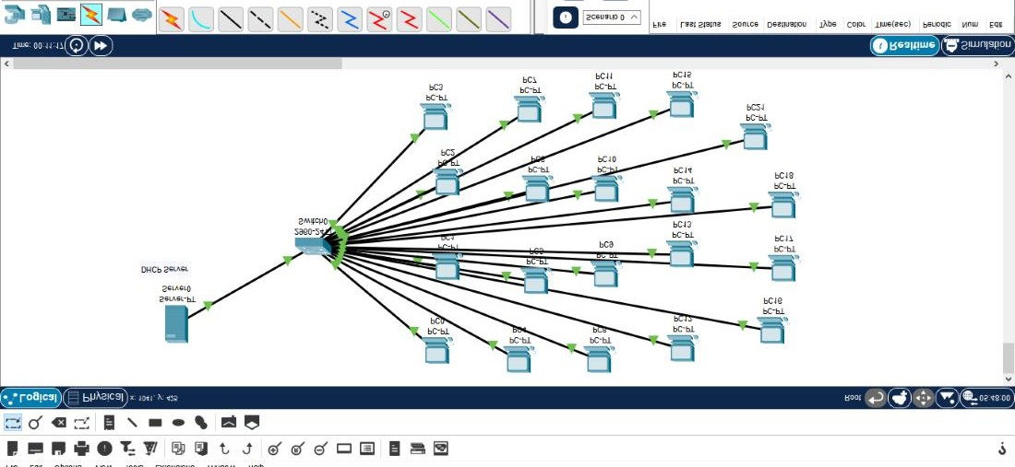

### Step 4:

We’re considering the server as a DHCP server. Click on server, go to Desktop, and then click on IP configuration. Give an IP address, subnet mask, and default gateway to the server.

|  |  |
| --- | --- |
| **IP Address** | **192.168.1.1** |
| **Subnet Mask** | **255.255.255.0** |
| **Default Gateway** | **192.168.1.254** |

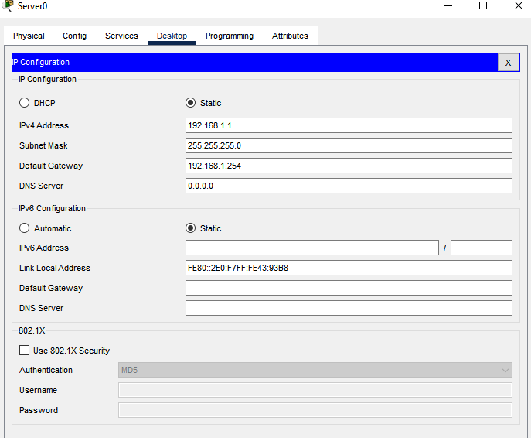

### Step 5:

Click again on the server, click on the services section, and then go to DHCP. Turn on the DHCP services and then enter the default gateway, starting IP address, subnet mask, and a number of devices, and then SAVE it. Now, the DHCP server will automatically assign IP, subnet mask, etc. to the PCs.

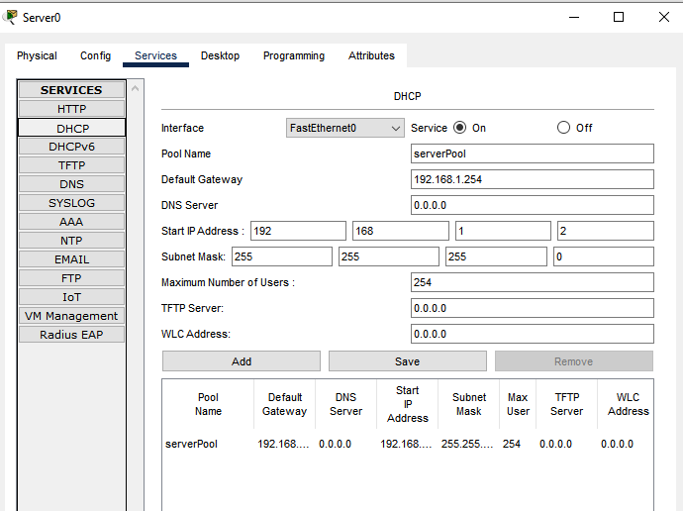

### Step 6:

Click on any PC, go to Desktop, and then click on the IP configuration section. Click on DHCP and it will request the IP address, subnet mask, etc. from the DHCP server and it will automatically assign all these to the PC.

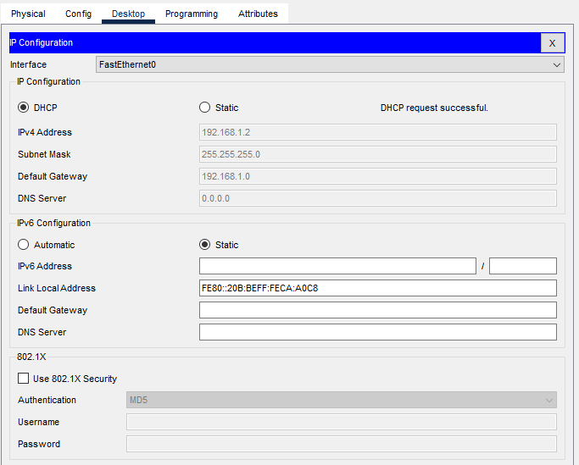

### Step 7:

Do this for all the PCs. One can also use the ping command to check the communication between all PCs.

**For example, From PC0 ping 192.168.1.5**

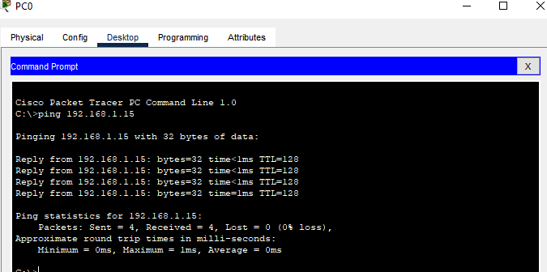

**Results:**

The result of a computer lab setup using Cisco Packet Tracer is a fully operational network environment with interconnected computers, switches, and routers. This lab facilitates hands-on learning of networking concepts, VLAN segmentation, secure wireless access, DHCP/DNS services, and centralized server functionalities within a simulated setting.

**Experiment No: 03**

**Implement Star Topology with Basic Firewall Configuration in Cisco Packet Tracer**

# Star Topology:

**Aim:**

The aim for a star topology with basic firewall configuration using Cisco Packet Tracer is to create a secure and centralized network setup. In a star topology, all network devices are connected to a central hub, which allows for easy management and troubleshooting.

# Objectives:

The objective of implementing a star topology with basic firewall configuration using Cisco Packet Tracer is to create a secure and efficient network setup. It also establishes a robust and secure network infrastructure that promotes smooth data communication while safeguarding against potential security threats.

# Theory:

A star topology for a Local Area Network (LAN) is one in which each node is connected to a central connection point, such as a hub or switch. Whenever a node tries to connect with another node then the transmission of the message must be happening with the help of the central node. The best part of star topology is the addition and removal of the node in the network but too many nodes can cause suffering to the network.

A Cisco packet tracer is a simulation tool that is used for understanding the networks. The best part of the Cisco packet tracer is its visualization you can see the actual flow of the message and understand the workflow of the network devices. Implementation of Star Topology using Cisco Packet Tracer is done using Switch.

A firewall is a hardware or software network security device that monitors all incoming and outgoing traffic based on a defined set of security rules, it accepts, rejects, or drops that specific traffic.

**Accept:** Allow traffic.

**Reject:** Block traffic but respond with “reachable error”.

**Drop:** Block unanswered traffic firewall establishes a barrier between secure internal networks and untrusted external networks, such as the Internet.

**Tools:** 3 PC's, 1 PT-Server, 1 PT -Switch

# Procedure:

**Steps to Configure and Verify Firewall in Cisco Packet Tracer:**

### Step 1:

First, open the Cisco packet tracer desktop and select the devices given below:

|  |  |  |  |
| --- | --- | --- | --- |
| **S.NO** | **Device** | **Model Name** | **Quantity** |
| **1.** | PC | PC | 3 |
| **z2.** | server | PT-Server | 1 |
| **3.** | switch | PT-Switch | 1 |

IP Addressing Table:

|  |  |  |  |
| --- | --- | --- | --- |
| **S.NO** | **Device** | **IPv4 Address** | **Subnet Mask** |
| **1.** | Server | 1.0.0.1 | 255.0.0.0 |
| **2.** | PC0 | 1.0.0.2 | 255.0.0.0 |
| **3.** | PC1 | 1.0.0.3 | 255.0.0.0 |
| **4.** | PC2 | 1.0.0.4 | 255.0.0.0 |

Then, create a network topology as shown below the image.

Use an Automatic connecting cable to connect the devices with others.

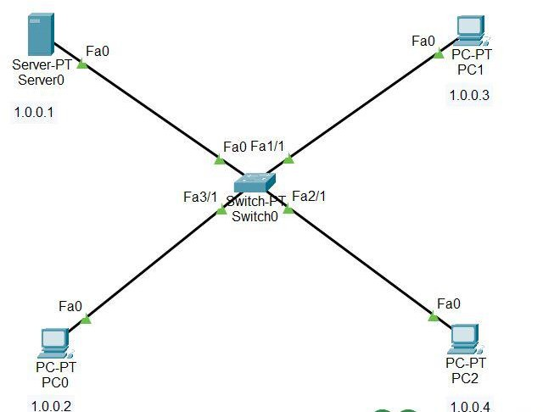

### Step 2:

Configure the PCs (hosts) and server with IPv4 address and Subnet Mask according to the IP addressing table given above.

To assign an IP address in PC0, click on PC0.

Then, go to desktop and then IP configuration and there you will IPv4 configuration.

Fill IPv4 address and subnet mask.

Repeat the same procedure with the server

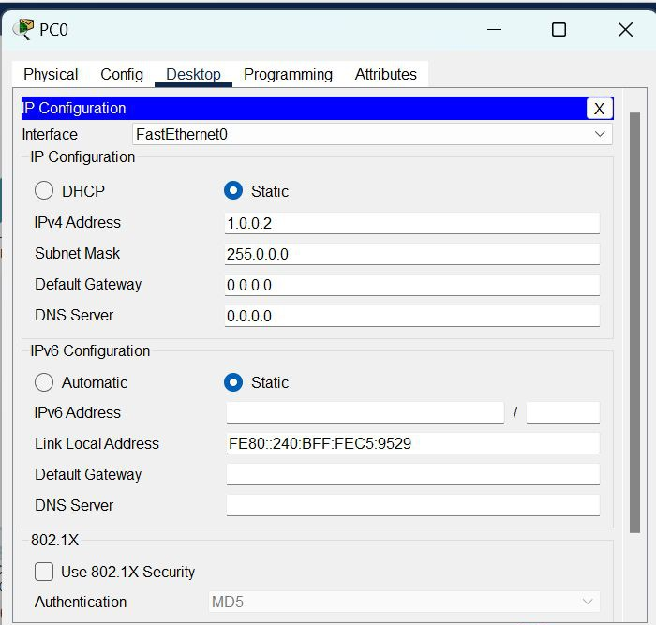

Assigning an IP address using the ipconfig command, or we can also assign an IP address with the help of a command.

Go to the command terminal of the PC.

Then, type iPConfig <IPv4 address><subnet mask><default gateway>(if needed) Example: ipconfig 1.0.0.2 255.0.0.0

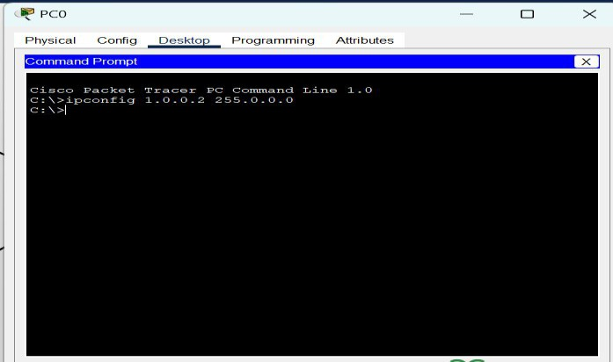

Repeat the same procedure with other PCs to configure them thoroughly.

### Step 3:

Configuring the firewall in a server and blocking packets and allowing web browser.

* Click on server0 then go to the desktop.
* Then click on firewall IPv4.
* Turn on the services.
* First, Deny the ICMP protocol and set remote IP to 0.0.0.0 and Remote wildcard mask to 255.255.255.255.
* Then, allow the IP protocol and set remote IP to 0.0.0.0 and Remote wildcard mask to 255.255.255.255.
* And add them.

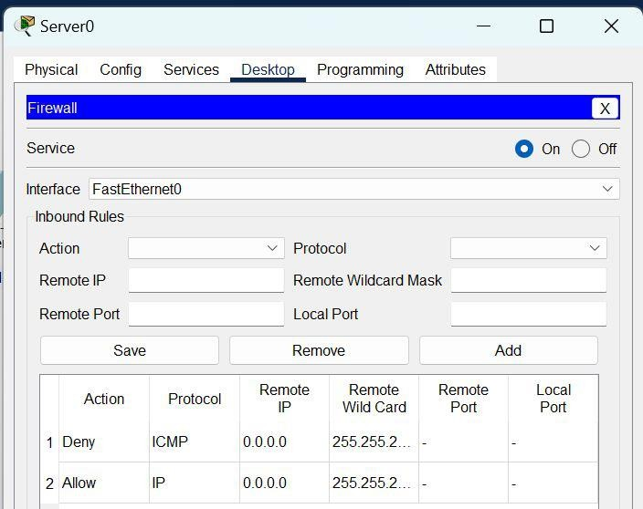

### Step 4:

Verifying the network by pinging the IP address of any PC. We will use the ping command to do so.

* First, click on PC2 then Go to the command prompt.
* Then type ping <IP address of targeted node>.
* We will ping the IP address of the server0.
* As we can see in the below image we are getting no replies which means the packets are blocked.

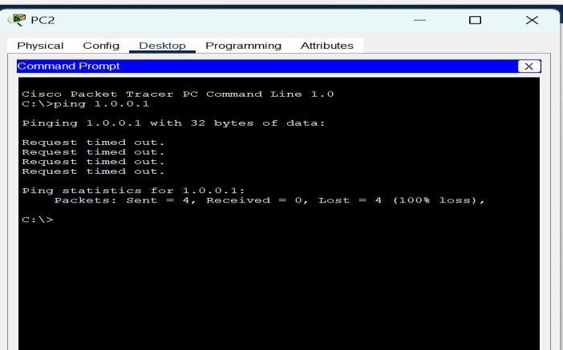

# Results:

The result of implementing a star topology with basic firewall configuration using Cisco Packet Tracer will be a secure and centrally managed network. It also results in setting up more secure, efficient, and manageable network infrastructure, which is crucial for maintaining the integrity and availability of network resources while protecting against security threats.

**Experiment No: 04**

**Configure The DHCP And Web Server Using Cisco Packet Tracer**

# Aim:

The aim to configure the DHCP and web server using Cisco Packet Tracer is to create a simulated network environment where devices can dynamically obtain IP addresses from the DHCP server and access the web server's content through a web browser.

# Objectives:

The objective of configuring the DHCP and web server using Cisco Packet Tracer is to gain hands-on experience in setting up and managing essential network services.

# Theory:

**DHCP:** It is an Internet control protocol used to assign an IP address to any appliance, or node, on an internet network so they can transmit data using IP. DHCP automatically handles these configurations rather than requiring network administrators to manually set IP addresses to all network devices. DHCP can be executed on small local networks, as well as large company networks.

**Tools:** 3 PC's, 2 LAPTOP, 1 PT- Server, 1 PT-Switch

# Procedure:

### Step 1:

First, open the cisco packet tracer desktop and select the devices given below:

|  |  |  |  |
| --- | --- | --- | --- |
| **S.NO** | **Device** | **Model Name** | **Qty**  **.** |
| **1.** | PC  LAPTO P | PC LAPTOP | 3  2 |
| **2.** | switch | PT-switch | 1 |
| **3.** | server | Server-PT | 1 |

IP Addressing Table

|  |  |  |  |  |  |
| --- | --- | --- | --- | --- | --- |
| **S.NO** | **Device** | **IPv4**  **Address** | **Subnet Mask** | **Default Gateway** | **DNS** |
| **1.** | server0 | 192.168.0.1 | 255.255.255.0 | 192.168.5.1 | nil |

Then, create a network topology as shown below the image.

Use an copper straight -Through connecting cable to connect the devices with other

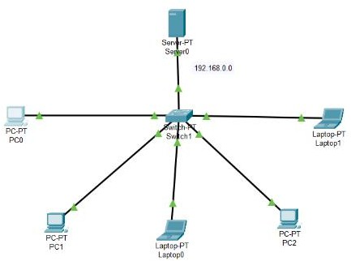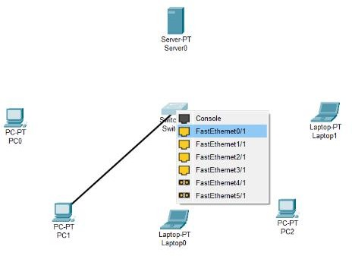

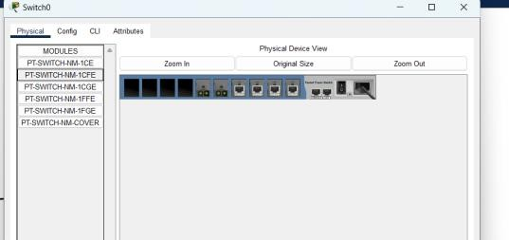

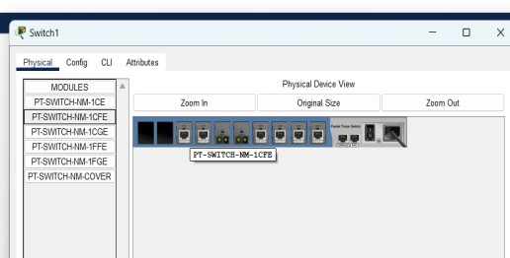

### Step 2:

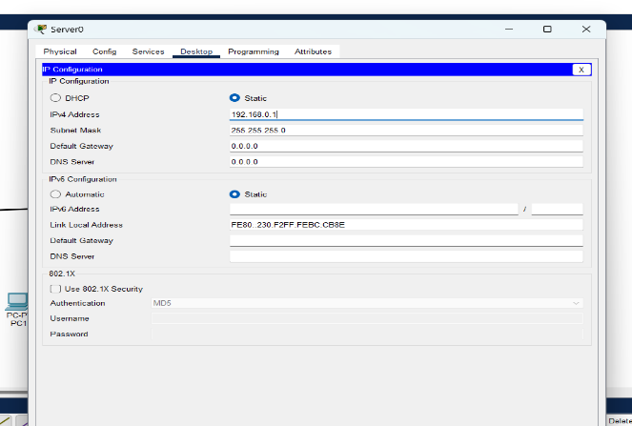Server0 with IPv4 address and Subnet Mask according to the IP addressing table given above. To assign an IP address, click on the device.

Then, go to desktop and IP configuration and there you will find IPv4 configuration. Fill IPv4 address and subnet mask and other inputs.

### Step 3:

Go to services in Server0 and configure DHCP

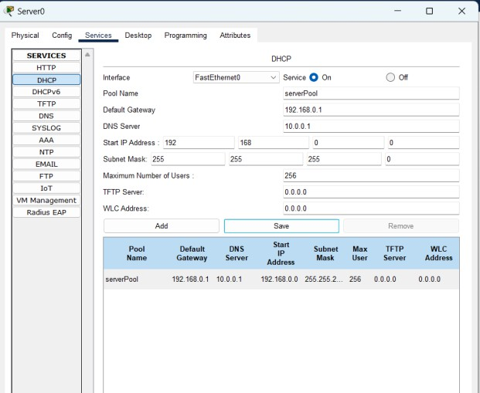

### Step 4:

Set PC0, PC1, PC2, LAPTOP-0, LAPTOP-1 to DHCP Configuration and send a simple PDU to check the status

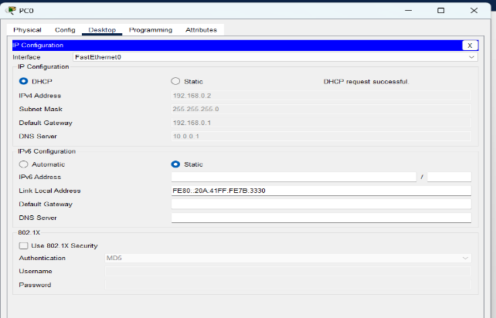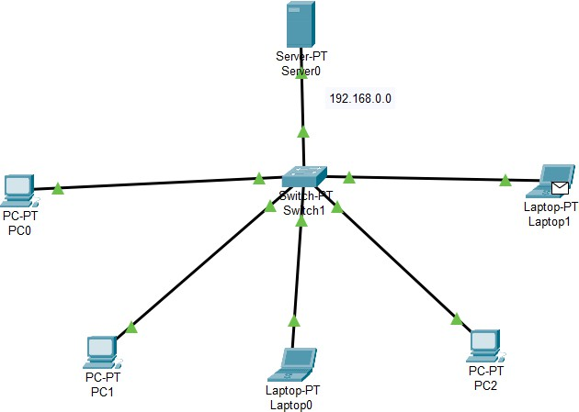

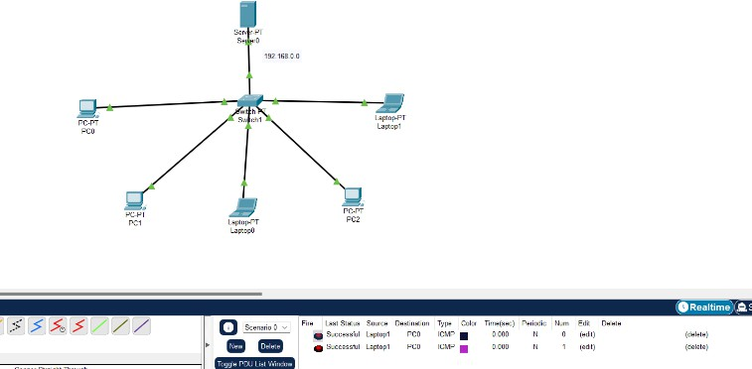

### Step 5:

Configure the HTTP sever0 To configure the HTTP server.

Go to services then click on HTTP

Then delete all of the files except the index.html and edit it.

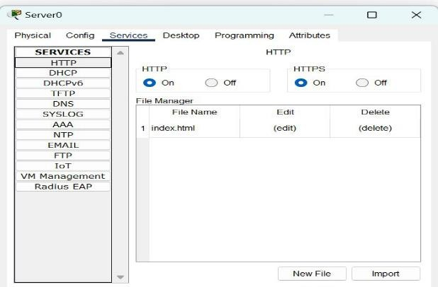

### Step 6:

Verify the server by using the web browser in the Host. Enter the IP address of server0 and click on GO.

It will show the results.

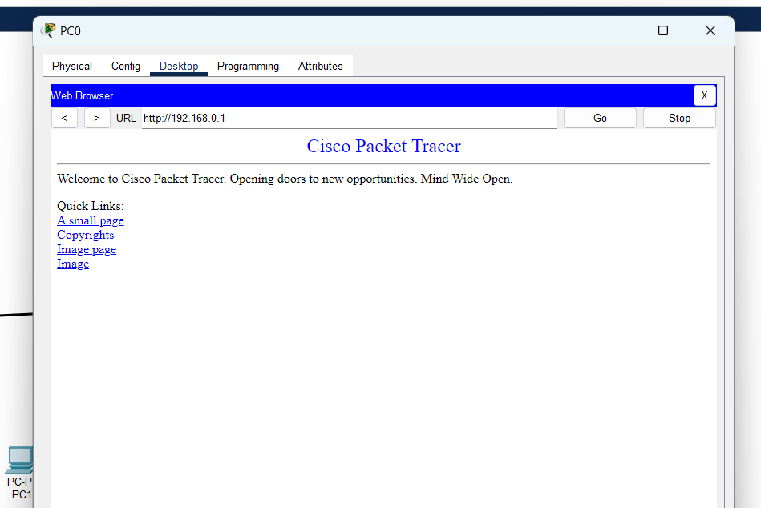

# Result:

The successful configuration of the DHCP and web server using Cisco Packet Tracer will result in a functional network environment where devices can easily connect and communicate, and users can access web-based services hosted on the web server without the need for manual IP address configuration.

**Set up a small organization and implement FTP configuration using CISCO packet tracer.**

# Aim:

The experiment is to create and configure a small organizational network using Cisco Packet Tracer. This experiment aims to provide hands-on experience in network design, topology creation, device configuration, and communication setup within a controlled environment

# Objectives:

Design a small-scale organizational network that includes routers, switches, and end devices, considering factors like scalability, redundancy, and efficient communication. Configure IP addresses and hostnames for routers, switches, and end devices to enable proper communication within the network. Implement subnetting to efficiently allocate IP addresses and manage network traffic. Choose and configure a routing protocol to enable dynamic routing and efficient data exchange between devices.

# Theory:

**Router:** It helps to direct data from your computer to where it needs to go. Imagine it as a map that tells your computer how to reach other computers on the internet.

**Server***:* A server is like a helpful assistant that stores and shares things.

**Switch:** A switch is like a smart connector for computers in a network. A switch helps devices in a group talk to each other directly.

**Tools:** Router, server, Copper wire cables, 4 Switches and 6 PC’S

# Small organization:

**Procedure:**

### Step 1:

Open the Cisco Packet Tracer.

### Step 2:

After opening the Cisco Packet tracer, add a router, 4 switches, 6 PCs, and a server to build a network for a small organization.

|  |  |
| --- | --- |
| **Router** | 1 |
| **Switch** | 4 |
| **Server** | 1 |
| **PC** | 6 |

There are four different networks in this organization: 192.168.1.0/24.

192.168.2.0/24.

192.168.3.0/24.

192.168.4.0/24.

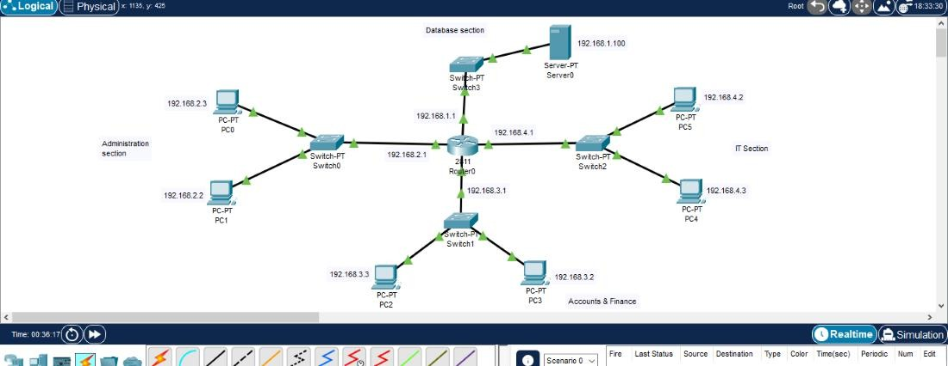

### Step 3:

Connect the router with 4 switches, 3 switches are connected with 2PCs each, and 1 switch is connected with the server using a cable. There are four different networks in this organization: 192.168.1.0/24, 192.168.2.0/24, 192.168.3.0/24, and 192.168.4.0/24.

### Step 4:

Give IP, subnet mask, default gateway, and DNS server to each PC and server in this network. To assign IP to each PC and server, click on each PC, go to Desktop, and then click on IP configuration.

|  |  |  |  |  |
| --- | --- | --- | --- | --- |
| **Components** | **IP Address** | **Subnet Mask** | **Default Gateway** | **DNS server** |
| PC0 | 192.168.2.3 | 255.255.255.0 | 192.168.2.1 | 192.168..1.100 |
| PC1 | 192.168.2.2 | 255.255.255.0 | 192.168.2.1 | 192.168.1.100 |
| PC2 | 192.168.3.3 | 255.255.255.0 | 192.168.3.1 | 192.168.1.100 |
| PC3 | 192.168.3.2 | 255.255.255.0 | 192.168.3.1 | 192.168.1.100 |
| PC4 | 192.168.4.3 | 255.255.255.0 | 192.168.4.1 | 192.168.1.100 |
| PC5 | 192.168.4.2 | 255.255.255.0 | 192.168.4.1 | 192.168.1.100 |
| Server | 192.168.1.100 | 255.255.255.0 | 192.168.1.1 | 192.168.1.100 |

### For example, For PC0:

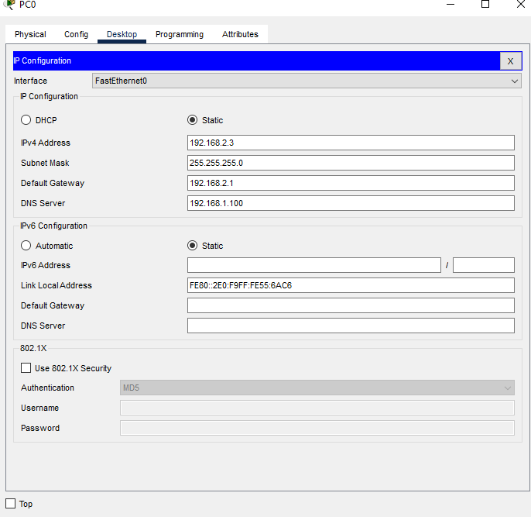

**Step 5:**

Now, configure the router according to the details given below and then turn on the port status.

|  |  |  |
| --- | --- | --- |
| FastEthernet0/0 | 192.168.2.1 | 255.255.255.0 |
| FastEthernet0/1 | 192.168.3.1 | 255.255.255.0 |
| FastEthernet1/0 | 192.168.1.1 | 255.255.255.0 |
| FastEthernet1/1 | 192.168.4.1 | 255.255.255.0 |

### For example, For FastEthernet0

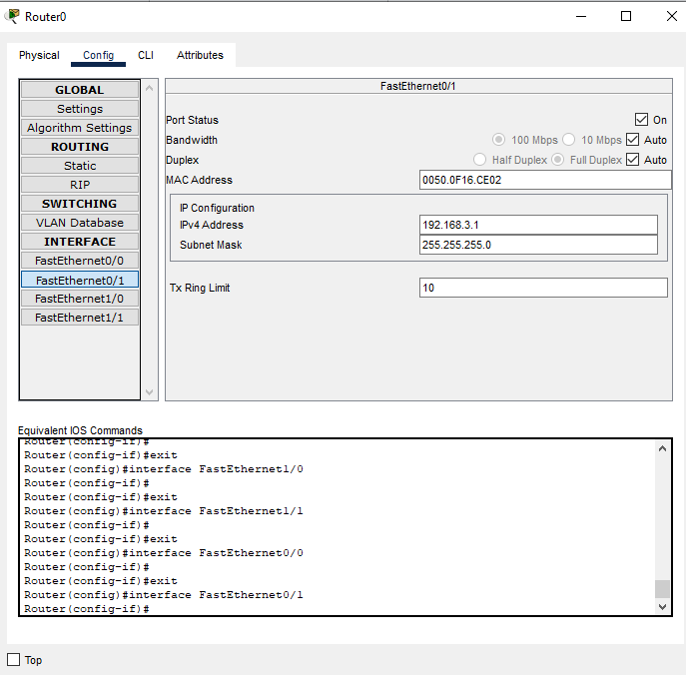

**Step 6:**

Now, we’ve to maintain the DNS server. For this click on the server, go to the services section, and then click on DNS. Turn on the DNS server, enter any domain in the ‘Name’ section, For E.g.: “[www.google.com”](http://www.google.com/) enter the IP address of the server in the ‘Address section’, and then click on save.

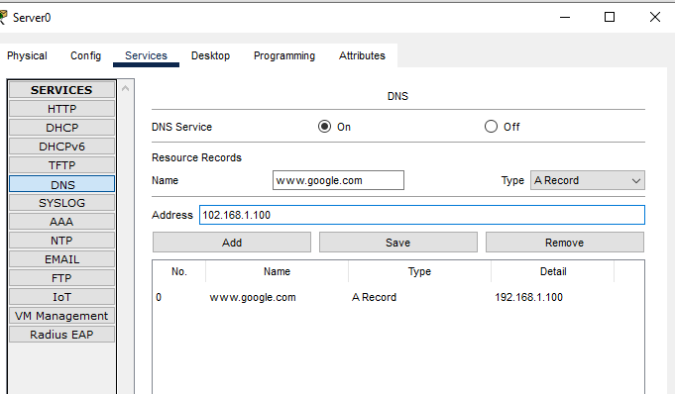

### Step 7:

Again, click on the server, go to services, and then click on HTTP. Turn on the HTTP and HTTPS services. You can also edit the index.html file which will show when you search the domain you entered in DNS in the web browser.

### Step 8:

To check the connection between PCs, present in different networks in this organization, you can use the ping command. Click on any PC, go to Desktop, and then click on the command prompt, enter the ping command, and check if they’re able to communicate with each other.

For example, ping 192.168.3.1

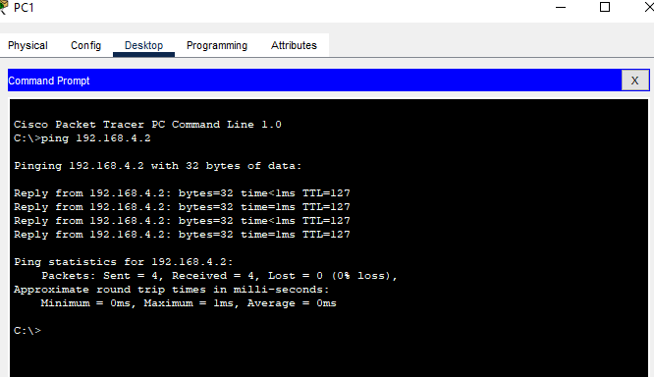

### Step 9:

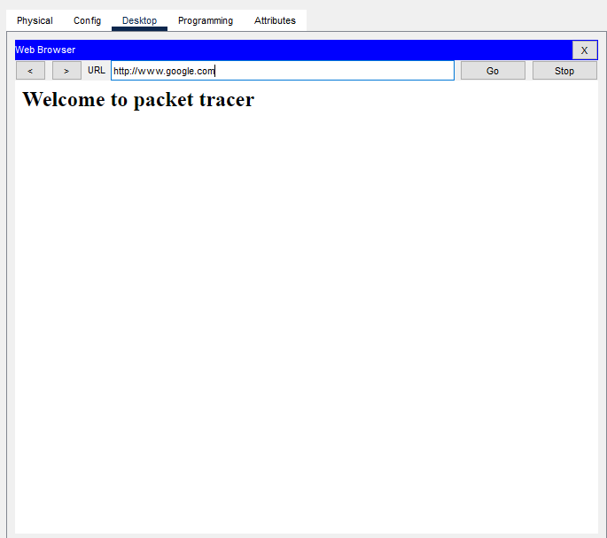Click on any PC, go to the Desktop section, and then open the web browser. Enter the domain or address you’ve given in the DNS server and it will show the index.html file from HTTP services.

This is how a small network for an organization with 4 different sections is created. One can add as many sections and networking devices as one want.

# Results:

On completion of the experiment, a functional small organizational network will be established using Cisco Packet Tracer. The network will demonstrate successful communication between devices, proper IP addressing, efficient routing, and basic security measures. The experiment will enhance understanding of network design principles, configuration techniques, and troubleshooting procedures, thereby building practical networking skills.

# FTP Configuration:

**Aim:**

The aim of this experiment is to configure and demonstrate the functionality of the File Transfer Protocol (FTP) within a simulated network environment using Cisco Packet Tracer. The experiment aims to provide experience in setting up, configuring, and using FTP for secure and efficient file transfers.

# Objective:

Set up an FTP server on a designated device within the network to facilitate file storage and sharing. Configure an FTP client on another device to establish connections with the FTP server and initiate file transfers. Create documentation outlining the FTP setup and configure with the server.

# Theory:

File Transfer Protocol (FTP) is a standard network protocol used to transfer files from one host to another over a TCP-based network, such as the Internet or an internal network. FTP Server: A device that stores and shares files, making them accessible to clients. FTP Client: A device that connects to an FTP server to upload, download, or manage files.

**Tools:** Router, Switch and two PC’S.

# Procedure:

### Step 1:

**Configuring Router0**

* Select a 2911 Router from Network Devices and drag and drop to the workspace.
* Select Router0 and Go to Config.
* Configure the GigabitEthernet0/0 by assigning IP address as 192.168.1.1 and subnet mask as 255.255.255.0 and turn on the port status
* Configure the GigabitEthernet0/1 by assigning IP address as 10.0.0.1 and subnet mask as 255.0.0.0 and turn on the port status.

### Router0 Command Line Interface:

Router>enable Router#

Router#configure terminal

Enter configuration commands, one per line. End with CNTL/Z. Router(config)#interface GigabitEthernet0/0

Router(config-if)#ip address 192.168.1.1 255.255.255.0 Router(config-if)#exit

Router(config)#interface GigabitEthernet0/1 Router(config-if)#ip address 10.0.0.1 255.0.0.0 Router(config-if)#shutdown

Router(config-if)#

%LINEPROTO-5-UPDOWN: Line protocol on Interface GigabitEthernet0/0, changed state to up

%LINK-5-CHANGED: Interface GigabitEthernet0/1, changed state to up

%LINEPROTO-5-UPDOWN: Line protocol on Interface GigabitEthernet0/1, changed state to up

### Step 2:

**Configuring PCs**

* Select two PC-PT type PCs from End devices and drag and drop to the workspace.
* Select PC0 and go to FastEthernet0 in config and assign IP address and subnet mask for the PC0 as 192.168.1.2, 255.255.255.0
* Select PC1 and go to FastEthernet0 in config and assign IP address and subnet mask for the PC1 as 192.168.1.3, 255.255.255.0
* For both the PCs (PC0, PC1) go to Global settings in config and Assign default gateway as 192.168.1.1

### Step3:

**Configuring Server0**

* Select a server from End devices and drag and drop to the workspace.
* Go to the global settings in config and assign default gateway as 10.0.0.1
* Go to FastEthernet0 and assign IP address and subnet mask as 10.0.0.2, 255.0.0.0
* Go to services and open FTP Service.
* Go to user setup and create a username and password.
* Select all the permissions (Write, Read, Delete, Rename, List) and add the user.

**User setup:**

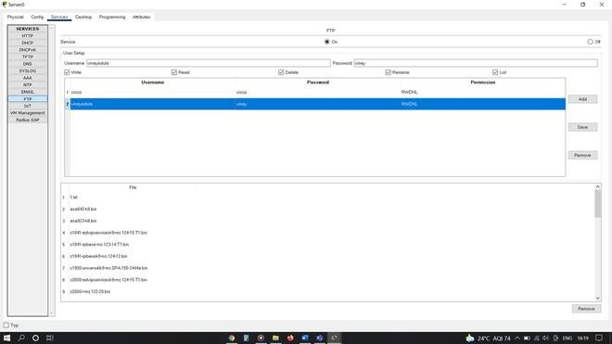

**Step 4:**

**Configuring Switch and Making connections**

* + Select a 2950-24 Switch from the network devices and drag and drop to the workspace.
  + Connect FastEthernet0 port of PC0 to the FastEthernet0/1 port of switch0 using Copper Straight-Through cable.
  + Connect FastEthernet0 port of PC1 to the FastEthernet0/2 port of switch0 using Copper Straight-Through cable.
  + Connect FastEthernet0/3 port of switch0 to the GigabitEthernet0/0 of Router0 using Copper Straight-Through cable.
  + Connect GigabitEthernet0/1 port of Router0 to the FastEtherner0 of server0 using Copper Straight-Through cable.

**Router Configuration Table:**

|  |  |  |  |  |
| --- | --- | --- | --- | --- |
| **Device Name** | **IP address GigabitEthernet0/ 0** | **Subnet Mask** | **IP Address Gigabit Ethernet0/1** | **Subne t Mask** |
| 2911  Router 0 | 192.168.1.1 | 255.255.255.  0 | 10.0.0.1 | 255.0.  0.0 |

**PC Configuration Table:**

|  |  |  |  |  |
| --- | --- | --- | --- | --- |
| **Device Name** | **Device Type** | **IP address** | **Subnet Mask** | **Default Gateway** |
| PC 0 | PC-PT | 192.168.1.2 | 255.255.255.0 | 192.168.1.1 |
| PC 1 | PC-PT | 192.168.1.3 | 255.255.255.0 | 192.168.1.1 |

**Designed Network topology:**

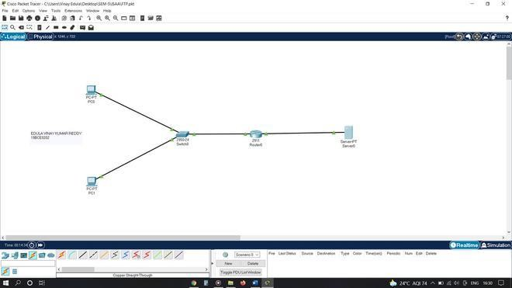

Checking connections from PC0 to the other hosts in the network using ping Command in Co mmand Prompt.

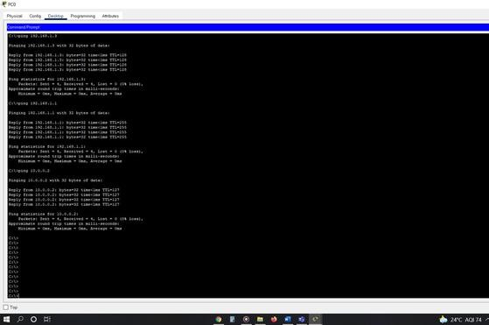

Checking connections from PC0 to the other hosts in the network using ping Command in Command Prompt.

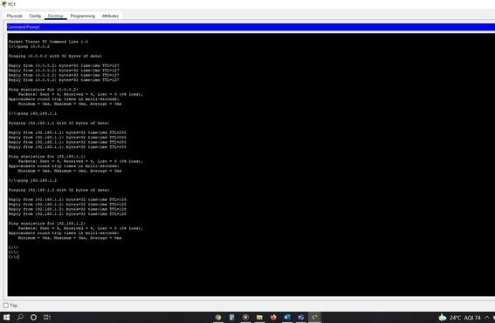

Creating a file named 2.txt for writing(uploading) into FTP Server.

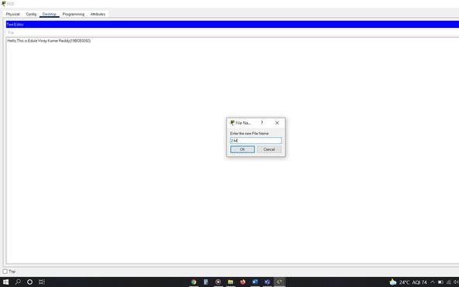

Writing(uploading) the file named 2.txt into FTP Server from PC0 using put 2.txt command and verifying this file transfer using dir command.

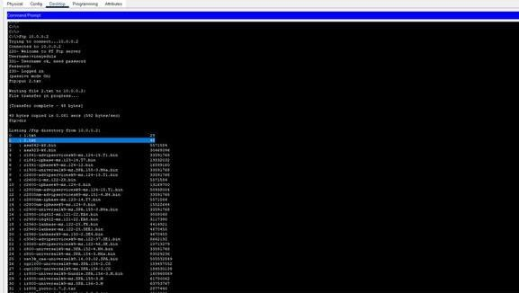

Reading (Downloading) the file named 2.txt present in FTP Server from PC1 using get 2.txt command and verifying this file transfer using dir command.

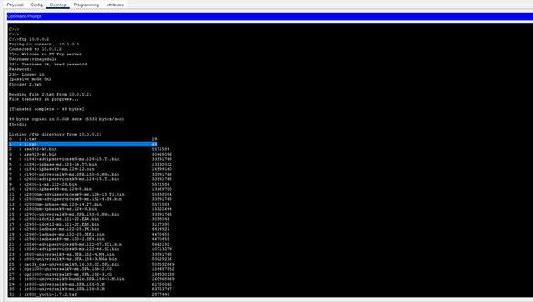

# Results:

On successful completion of the experiment, the network will feature a fully functional FTP setup. This will include a configured FTP server that allows secure file

**Aim:**

**Experiment No: 06 Implement ARP and DHCP Spoofing**

Implementation ARP spoofing and DHCP spoofing using Packet tracer

# Objective:

It's important to clarify that ARP spoofing and DHCP (Dynamic Host Configuration Protocol) spoofing are both considered unethical and potentially illegal activities when done without proper authorization and consent. These activities involve exploiting network vulnerabilities and can lead to various malicious outcomes. Therefore, I cannot provide assistance or guidance on using these techniques for unauthorized purposes.

However, I can provide you with information on how these techniques can be used in an educational and controlled environment with the proper ethical considerations and authorization

# Theory:

**DHCP Snooping:** DHCP (Dynamic Host Configuration Protocol) configuration is performed on routers to assign an IP address, subnet mask, gateway address ad DNS server address to the host systems. With this configuration, the dynamic IP address is assigned, which enables the administrator to easily connect a new host in the configured network.

In Cisco Packet Tracer, you can simulate and configure DHCP (Dynamic Host Configuration Protocol) to dynamically assign IP addresses and other network configuration settings to devices on a network. This is a fundamental feature in networking that helps streamline IP address management and network connectivity**.**

# Procedure:

### Step 1:

A network topology is created in the Cisco Packet Tracer, which includes a router, a switch, and three host systems connected to a network.

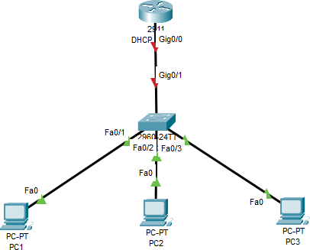

### Step 2:

Command Line Interface of the router is accessed and high-lighted commands are executed to successfully configure the DHCP. At first, the ‘IP DHCP pool pool_name’ command is executed. After this, the network address is defined along with its subnet mask. And further, the ‘default-router IP-address’ command is used to define the default route address.

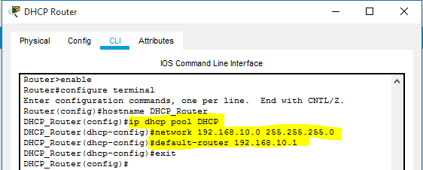

### Step3:

In this step, a range of IP addresses is excluded from the addresses defined in the subnet mask of the DHCP pool. Excluded IP addresses will be not assigned to any host system in the network.

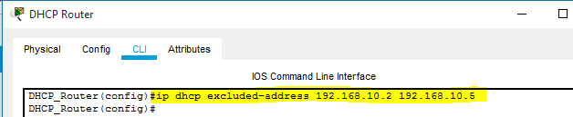

### Step 4:

The interface of the router connected with the switch is assigned with the IP address defined as the default router during the DHCP configuration. This route will be taken by the data packets to reach their destination system. Also, the ‘no shutdown command is used to change the state of the connected interface to up.

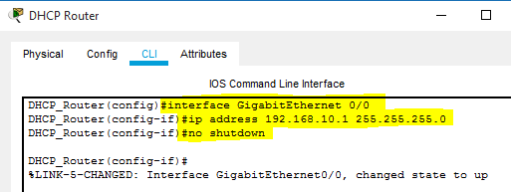

### Step 5:

A successful connection is established between all the devices connected in a network. In further steps, host systems in the network are assigned with dynamic IP and default gateway address by the DHCP service configured on the router.

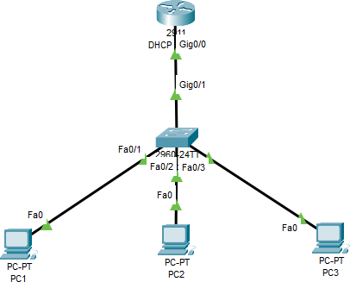

### Step 6:

Desktop settings of a host system are accessed and the DHCP option is selected. DHCP request forwarded by the system is acknowledged and IP address, associated subnet mask, and default gateway address are assigned to it.

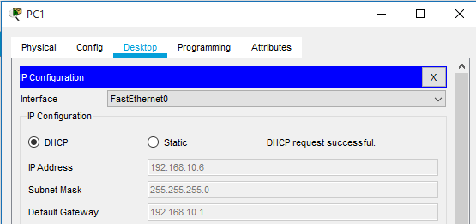

Another host system deployed in the network is assigned with required logical addresses through the DHCP server configured on Cisco Router. In addition, IP addresses defined in the excluded range are not assigned to the computer systems.

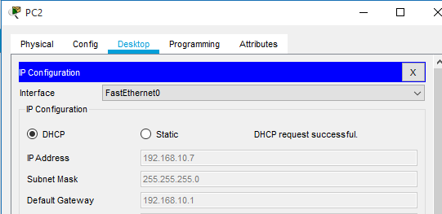

### Step 7:

To check the connectivity between the host systems, the ‘ping’ command is used to exchange data packets. All the data packets are successfully transferred, which ensures that a communication channel is established.

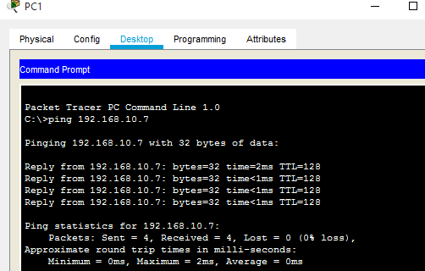

# ARP spoofing:

ARP spoofing is a type of attack in which a malicious actor sends falsified ARP (Address Resolution Protocol) messages over a local area network. This results in the linking of an attacker’s MAC address with the IP address of a legitimate computer or server on the network. Once the attacker’s MAC address is connected to an authentic IP address, the attacker will begin receiving any data that is intended for that IP address. ARP spoofing can enable malicious parties to intercept, modify or even stop data in-transit. ARP spoofing attacks can only occur on local area networks that utilize the Address Resolution Protocol.

In Cisco Packet Tracer, you can simulate ARP (Address Resolution Protocol) spoofing to understand how it works and its potential security implications. ARP spoofing is a technique used by attackers to send forged ARP messages to an Ethernet LAN, leading to incorrect or manipulated mapping between IP addresses and MAC addresses.

# Procedure:

### Step 1:

Set up the network topology

Open Cisco Packet Tracer and create a new empty network file.

Drag and drop two PCs (e.g., PC-A and PC-B)a router, a server onto the workspace. Connect the PCs to the router using Ethernet cables.

### Step 2:

Configure IP addresses and default gateway

Select PC-A and go to the "Config" tab in the right pane. Click on "Desktop" and select "IP Configuration."

Assign an IP address, subnet mask, and default gateway to PC-A. Note down the IP and MAC address of PC-A.

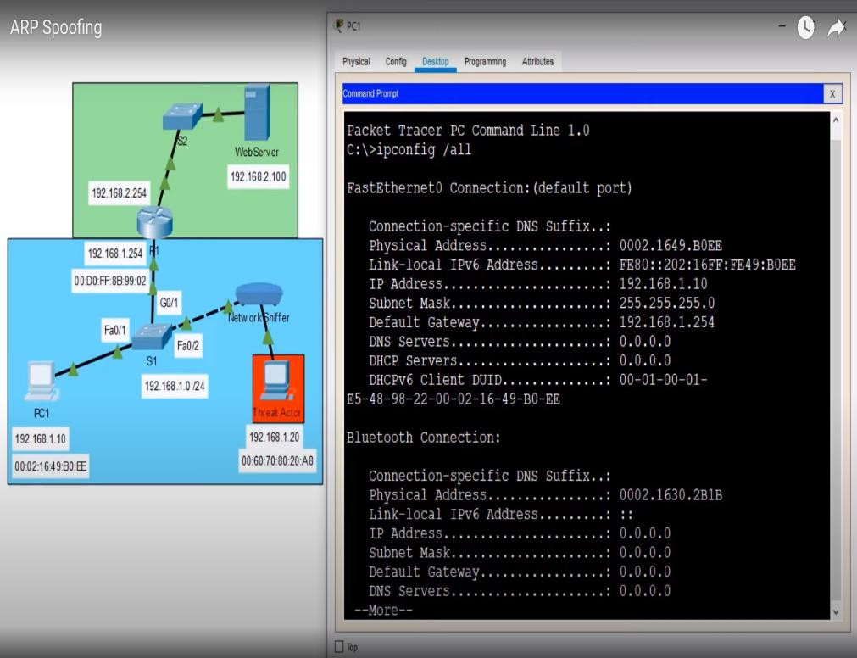

Repeat the same steps for PC-B, configuring a different IP address in the same subnet.

### Step 3:

Observe ARP table and ping test.

Go to the "Desktop" of PC-A and open the Command Prompt (CMD). Type the following command to view the ARP table: **arp –a.**

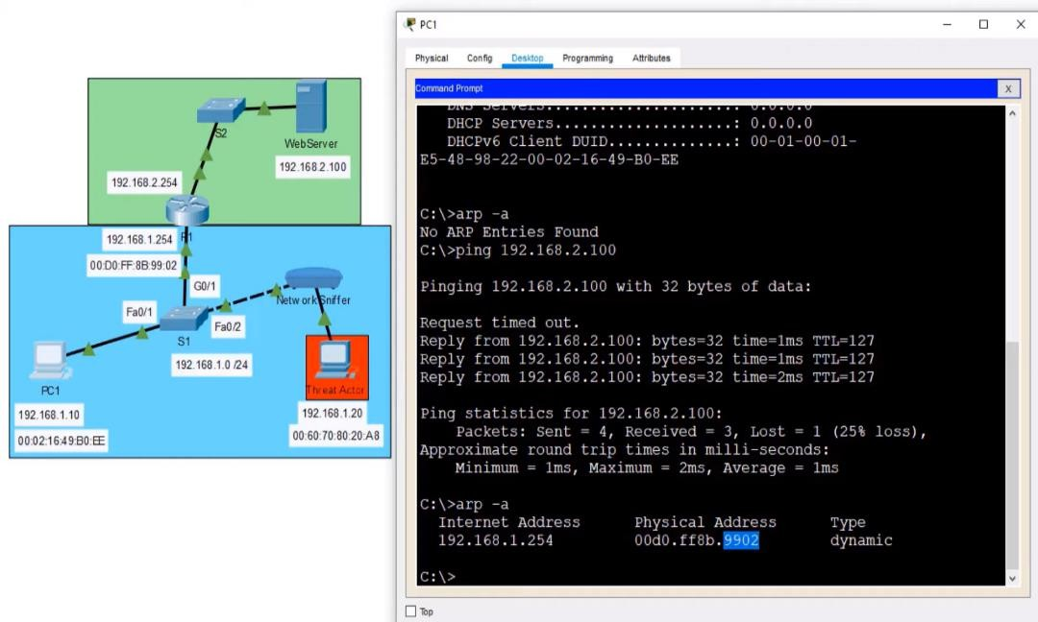

### Step 4:

Perform ARP spoofing.

Go to the "Desktop" of PC-B and open the Command Prompt (CMD). Find out PC-A's MAC address (the target) by using the **arp -a** command.

### Step 5:

Observe the ARP table after spoofing.

Go back to PC-A's Command Prompt and run **arp -a** again.

Now, you'll see that PC-A's ARP table has been manipulated, showing the MAC address of PC- B as the default gateway's MAC address instead of the actual router's MAC address.

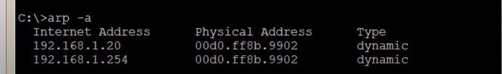

### Step 6:

Ping test after ARP spoofing.

Attempt to ping PC-B from PC-A again using the following command: **ping <PC-B-IP>**

You'll observe that the ping test succeeds, but the traffic is being intercepted by PC-B (the attacker) due to the ARP spoofing. This means that the attacker has successfully deceived PC-A into believing that PC-B is the default gateway.

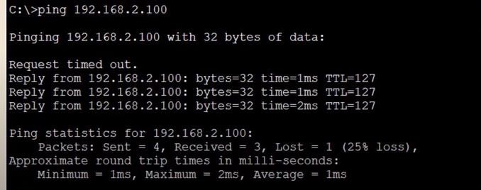

### Step 7:

Restore ARP table.

To restore the correct ARP table on PC-A, you can either wait for the ARP cache to time out (which might take a few minutes) or manually delete the spoofed entry.

## Results:

DHCP (Dynamic Host Configuration Protocol) is used to assign IP addresses and other network configuration settings to devices on a network, while ARP (Address Resolution Protocol) is used to map IP addresses to MAC addresses. Both protocols are essential for proper network communication and management. DHCP simplifies IP address assignment, and ARP ensures data is properly routed between devices. In conclusion, DHCP and ARP play vital roles in maintaining efficient and functional communication within a network.

**Experiment No: 07**

**Designing A Serial Port Configuration Using Cisco Packet Tracer**

# Aim:

This concerns the step-by-step designing of serial port configuration in cisco packet tracer using serial interfaces se0/0/0 or se0/0/1. It will also show how to check the network connectivity by transferring PDU’s between remote PCs.

# Objective:

* To Configure serial port in cisco packet tracer using 2 routers and 2 PCs.
* Simulation of Designed Network Topology.
* To check the network connectivity by sending a simple PDU from PC0 to PC1.

# Theory:

The Serial Connection is used to create a WAN connection with the help of a service provider who offers a dedicated leased line to its customers.

Business organizations buy leased lines to establish a WAN connection to connect with different offices and business sites that could physically be thousands of miles apart. Businesses have to pay for these leased lines according to the service availed. And accordingly, the service providers charge for this service i.e. based on the bandwidth they offer to their client organizations.

In this , we will configure a Serial Connection between the routers. We will set up a clock rate at 64,000, which will provide the speed of 64 Kbps. In a real world, the DCE side of the cable is configured by the service provider. Generally, the clock speed is configured according to the availability of the bandwidth speed that the service provider is offering.

# Procedure:

### Step 1:

**Configuring PC0**

* Select a PC-PT type PC from End devices and drag and drop to the workspace.
* Select PC0 and go to FastEthernet0 in the config and assign an IP address and subnet mask for the PC0 as 192.168.10.2, 255.255.255.0 and turn on the port status.
* In config go to settings and assign Default gateway as 192.168.10.3

### Step 2:

**Configuring PC1**

* Select a PC-PT type PC from End devices and drag and drop to the workspace.
* Select PC1 and go to FastEthernet0 in the config and assign an IP address and subnet mask for the PC0 as 192.168.20.2, 255.255.255.0 and turn on the port status.
* In config go to settings and assign Default gateway as 192.168.20.3

### PC Configuration Table:

|  |  |  |  |  |
| --- | --- | --- | --- | --- |
| **Device** | **Host Name** | **IP address Fa0/0** | **Subnet Mask** | **Default gateway** |
| PC-PT | PC-0 | 192.168.10.2 | 255.255.255.0 | 192.168.10.3 |
| PC-PT | PC-1 | 192.168.20.2 | 255.255.255.0 | 192.168.20.3 |

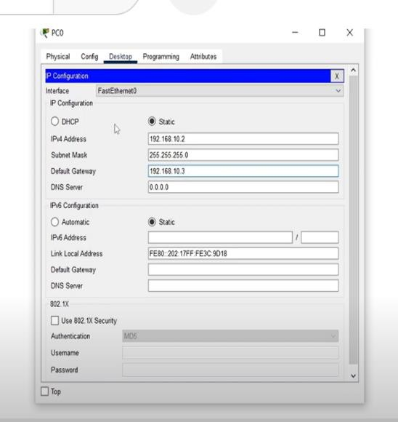 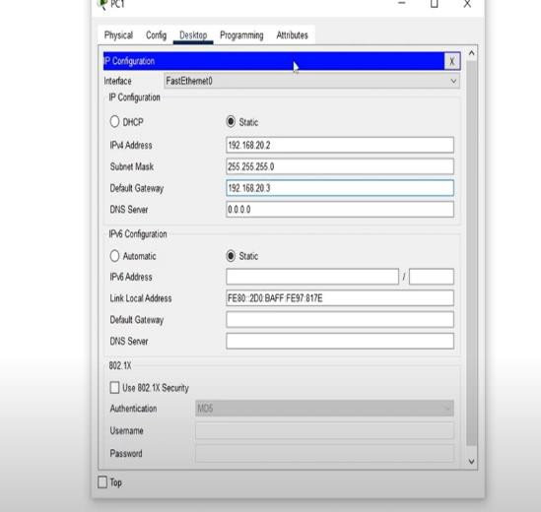

### Step 3:

**Configuring Router0**

* Select an PT- Router from Network Devices and drag and drop to the workspace.
* Select Router0 and Go to Physical.
* Switch off the PowerPoint of Router0 and then select the WIC-2T serial port connecter and establish a connection by placing it on the switch. After that turn on the PowerPoint of Router0.
* Select Router0 and Go to Config.
* Configure the FastEthernet0/0 by assigning IP address as 192.168.10.3 and subnet mask as 255.255.255.0 and turn on the port status
* Configure the Serial0/0/0 by assigning the IP address as 192.168.30.2 and subnet mask as 255.255.255.0 and turn on the port status.

### Step 4:

**Configuring Router1**

* Select an PT-Router from Network Devices and drag and drop to the workspace.
* Select Router1 and Go to Physical.
* Switch off the PowerPoint of Router1 and then select the WIC-2T serial port connecter and establish a connection by placing it on the switch. After that turn on the PowerPoint of Router1.
* Select Router1 and Go to Config.
* Configure the FastEthernet0/0 by assigning the IP address as 192.168.20.3 and subnet mask as 255.255.255.0 and turn on the port status.
* Configure the Serial0/0/0 by assigning the IP address as 192.168.30.3 and subnet mask as 255.255.255.0 and turn on the port status.

**Router Configuration Table:**

|  |  |  |  |  |
| --- | --- | --- | --- | --- |
| **Device** | **Host Name** | **IP-address Fa0/0** | **IP-address Se0/0/0** | **Subnet Mask** |
| PT-  Router | Router-0 | 192.168.10.3 | 192.168.30.2 | 255.255.255.0 |
| PT-  Router | Router-1 | 192.168.20.3 | 192.168.30.3 | 255.255.255.0 |

**Step 5:**

**Making connections**

* Connect PC0 with Router0 using copper cross-over wire.
* Connect Router0 with Router1 using DCE cable.
* Connect PC1 with Router1 using copper cross-over wire.
* To tell the routers about indirectly connected networks use the IP route command in CLI.

### CONFIGURATION ON ROUTER0 Say R1:

Router>enable Router#config t

Enter configuration commands, one per line. End with CNTL/Z. Router(config)#hostname R1

R1(config)#int fa0/0

R1(config-if)#ip address 10.0.0.1 255.0.0.0

R1(config-if)#no shut R1(config-if)#exit R1(config)#int se0/0/0

R1(config-if)#ip address 20.0.0.1 255.0.0.0

R1(config-if)#clock rate 64000 R1(config-if)#no shut

### CONFIGURATION ON ROUTER1 Say R2:

Router>enable Router#config t

Enter configuration commands, one per line. End with CNTL/Z. Router(config)#hostname R2

R2(config)#int fa0/0

R2(config-if)#ip address 30.0.0.1 255.0.0.0 R2(config-if)#no shut

R2(config-if)#exit R2(config)#int se0/0/0

R2(config-if)#ip address 20.0.0.2 255.0.0.0 R2(config-if)#no shut

### Now again go back to Router R1 and configure route in global configuration mode:

R1(config)#ip route 30.0.0.0 255.0.0.0 20.0.0.2

### Now again go back to Router R2 and configure route in global configuration mode.

R2(config)#ip route 10.0.0.0 255.0.0.0 20.0.0.1

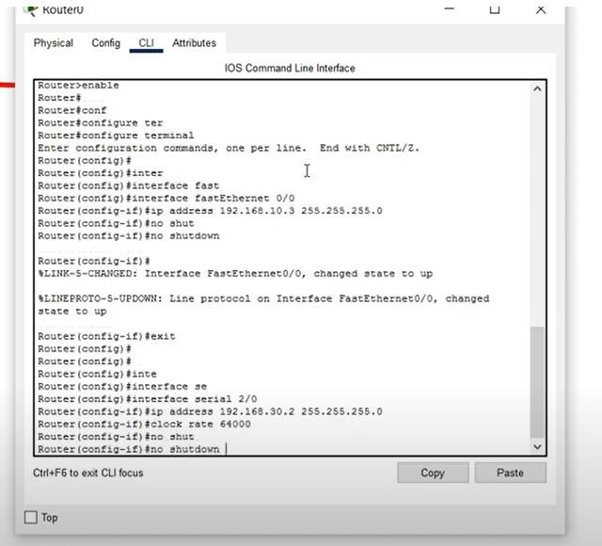 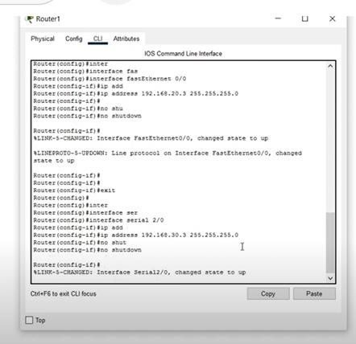

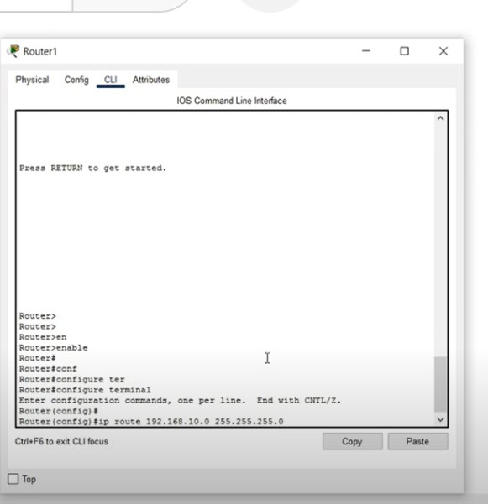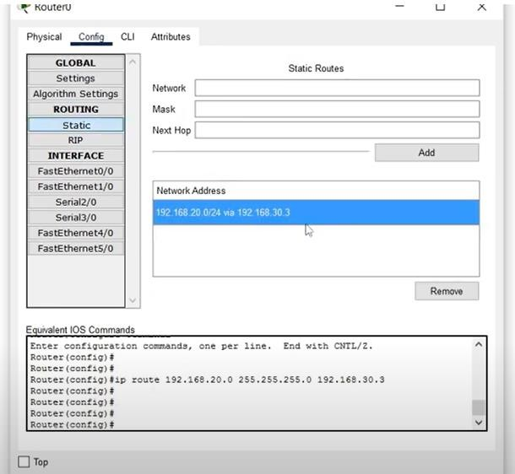

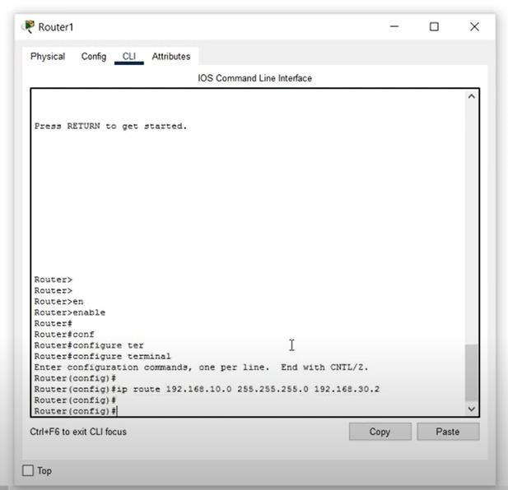

**Sending packets:**

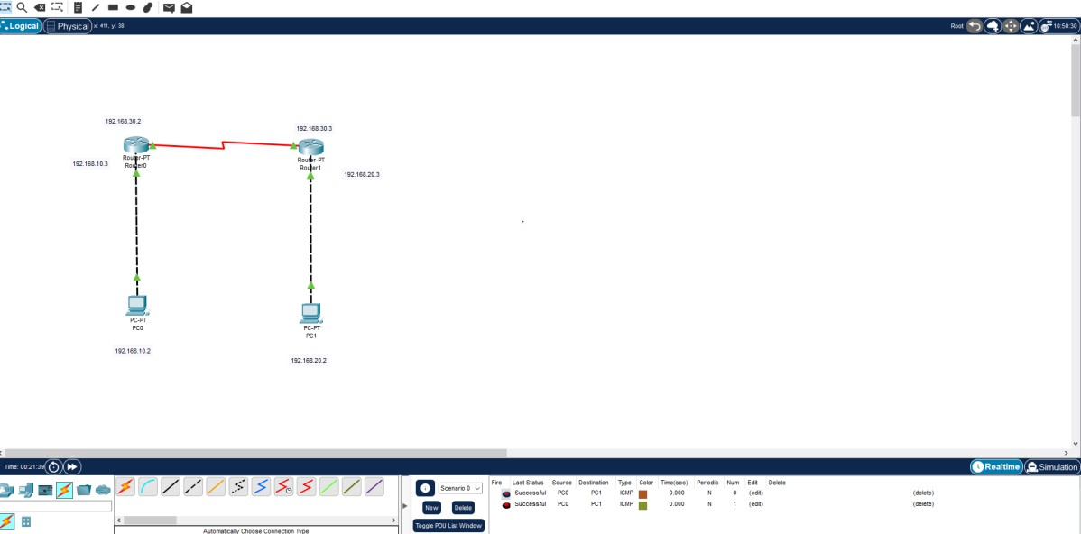

**Results:**

Designing a serial port configuration in Cisco Packet Tracer using 2 PCs and 2 routers allows you to establish a serial connection between the routers, simulating a real-world networking scenario. This configuration can help you learn about serial communication, routing, and network connectivity. It enables the routers to exchange data over a serial link, enhancing your understanding of network setups and configurations.

**Experiment No: 08 Password Cracking Using Hydra**

# Aim:

To crack the password using Hydra tool.

# Objective:

The tool is a free one that has a lot of advantages because it is a powerful one to use for the specific task of performing some activities that are related to penetration testing.

Our business objectives are accomplished using the tool as Hydra covers our needs for a free password cracking tool.

# Hardware/Software required:

Kali Linux

# Theory:

According to Wikipedia, Hydra is a parallelized network logon cracker. It is available on a number of Penetration Testing Linux distributions such as Kali Linux, Parrot OS, Black Arch, and Backbox. Hydra has the ability to perform attacks against various different network services including Remote Desktop,

Secure Shell, and many others. It is also capable of performing brute force attacks against web applications.

# Procedure:

### Step1:

In metasploitable

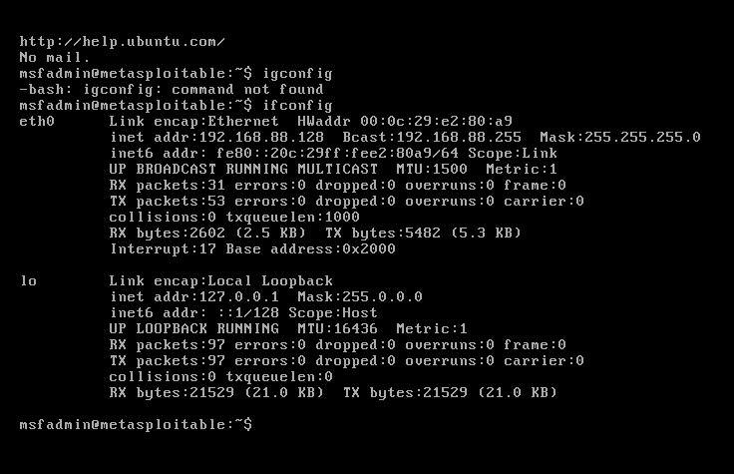

### Step 2:

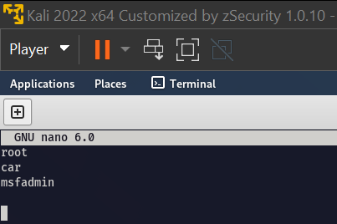Create two files nano user.txt

nano pass.txt

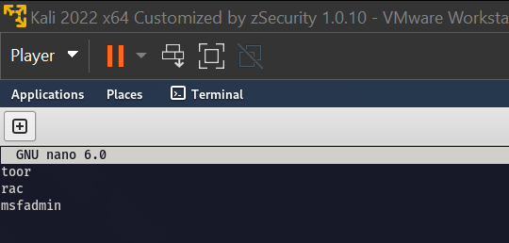

# Output:

hydra -L hydra -L word.txt -P word.txt ftp://192.168.123.129 (We get both username and password)

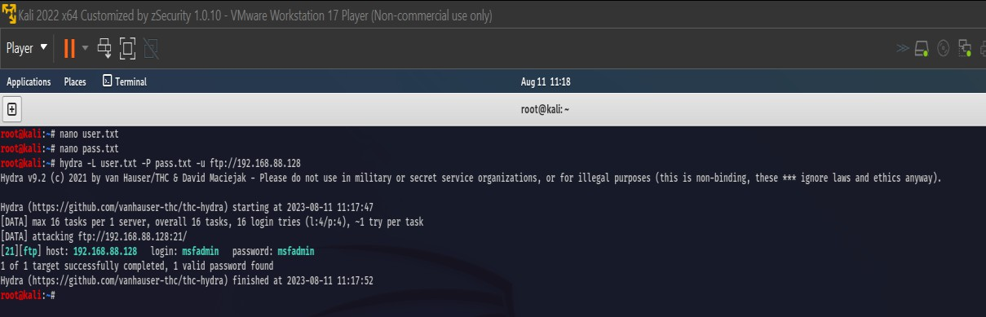

# Conclusion:

* Hydra is a parallelized network logon cracker.
* It is available on a number of Penetration Testing Linux distributions such as Kali Linux, Parrot OS, Black Arch, and Backbox.
* Hydra has the ability to perform attacks against various different network services including Remote Desktop, Secure Shell, and many others.
* It is also capable of performing brute force attacks against web applications

**Experiment No: 09**

**Online Password Cracking Attack Using Python**

# Aim:

Password cracking with Python: Online password cracking attack

# Objectives:

To leverage any capabilities offered to legitimate users to gain further access.

# Hardware/Software Required:

Kali Linux

# Theory:

**Hashing:** When a password has been “hashed” it means it has been turned into a scrambled representation of itself. A user’s password is taken and – using a key known to the site – the hash value is derived from the combination of both the password and the key, using a set algorithm.

To verify a user’s password is correct it is hashed and the value compared with that stored on record each time they login.

You cannot directly turn a hashed value into the password, but you can work out what the password is if you continually generate hashes from passwords until you find one that matches, a so-called brute-force attack, or similar methods.

### SHA256(Secure Hash Algorithm 2):

SHA-256 is a more secure and newer cryptographic hash function that was launched in 2000 as a new version of SHA functions and was adopted as FIPS standard in 2002. It is allowed to use a hash generator tool to produce a SHA256 hash for any string or input value. Also, it generates 256 hash values, and the internal state size is 256 bit and the original message size is up to 2 64 - 1 bits. It is more secure than SHA1.

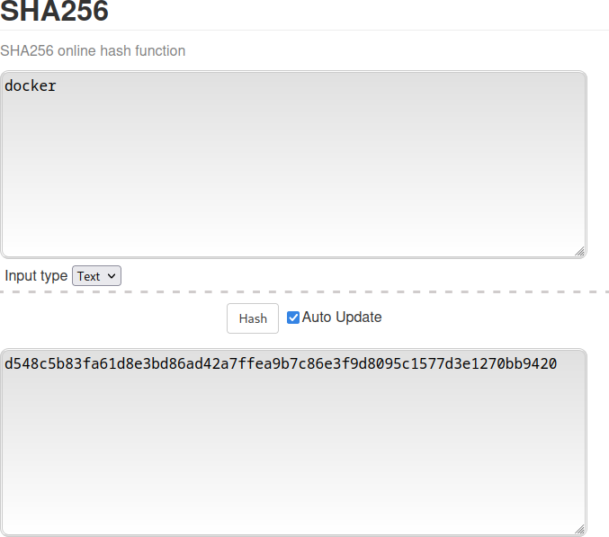

### Online password cracking

Online password cracking is attacking a computer system through an interface that it presents to its legitimate users by attempting to guess the login credentials. For instance, an attacker can try to guess a user’scredentials for a web application login page.

# PROGRAMS:

### Online password cracking attack

#!/usr/bin/python import hashlib import urllib.request flag=0

hashvalue=input("Enter a hash:") pasw=urllib.request.urlopen("https://raw.githubusercontent.com/danielmiessler/SecLists/ master/Passwords/Common-Credentials/10-million-password-list-top-100000.txt")

### link of 1lakh raw,link of raw password chrome ### paswd=(pasw.readlines())

for password in paswd: hashguess=hashlib.sha256(password.strip()).hexdigest() if hashguess==hashvalue:

print("The Password is",password.decode()) flag=1

break if(flag==0):

print("Password not found in the list")

**OUTPUT:**

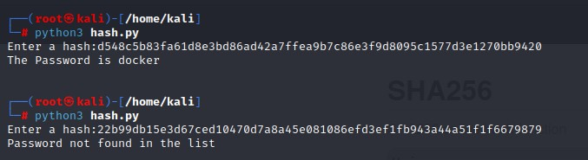

# Conclusion:

Passwords are already a weak form of authentication. If a user is using a password so weak that it can be recovered by a slow, online attack, that’s a real problem! But even “strong” passwords, if they have been recovered from a breach hack, are still vulnerable to cracking. The best defense against an online attack is to lock out the attacked account after a handful of unsuccessful login attempts. Not only can this stop an Online Password Cracking attack and dictionary attack dead in its tracks, it can also alert an administrator that such an attack is being carried out.

**Aim**:

**Experiment No: 10**

**DDOS Attack Using Slowlories and Detection Using Wireshark**

The lab focuses on comprehending the exploitation of a server's resources through Slowloris- based Denial of Service (DoS) attacks by maintaining prolonged open connections, causing network disruption. Wireshark aids in attack detection by analysing network traffic.

# Objective:

The objectives include comprehending Slowloris attacks, establishing a test environment, simulating the attack, capturing network traffic, analyzing packet data to identify attack patterns, detecting Slowloris attacks, implementing detection filters, generating alerts, devising mitigation strategies, addressing ethical concerns, and documenting the entire process.

# Hardware/Software Required:

Kali Linux, Wireshark, Slowloris

# Theory:

**Slowloris** is a free and open-source tool available on GitHub. We can perform a denial-of- service attack using this tool. It’s a framework written in python. This tool allows a single machine to take down another machine’s web server it uses perfectly legitimate HTTP traffic. It makes a full TCP connection and then requires only a few hundred requests at long-term and regular intervals. As a result, the tool doesn’t need to spend a lot of traffic to exhaust the available connections on a server.

**Wireshark** is the world’s foremost and widely-used network protocol analyser. It lets you see what’s happening on your network at a microscopic level and is the de facto (and often de jure) standard across many commercial and non-profit enterprises, government agencies, and educational institutions.

# Uses of Slowloris:

* Slowloris sends multiple requests to the target as a result generates heavy traffic botnets.
* Slowloris can be used to perform DDoS attacks on any webserver.
* It is an open-source tool, so you can download it from GitHub free of cost.
* It uses perfectly legitimate HTTP traffic.
* A denial-of-service attack can be executed with the help of Slowloris by generating heavy traffic of botnets.

**Uses of Wireshark:**

* It is used by network security engineers to examine security problems.
* It allows the users to watch all the traffic being passed over the network.
* It is used by network engineers to troubleshoot network issues.
* It also helps to troubleshoot latency issues and malicious activities on your network.
* It can also analyse dropped packets.
* It helps us to know how all the devices like laptop, mobiles, desktop, switch, routers, etc., communicate in a local network or rest of the world.

# Installation and step-by-step implementation of Slowloris tool: Procedure:

### Step 1:

Open your Kali Linux and then Open your Terminal.

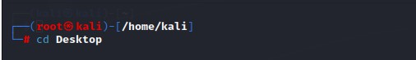

### Step 2:

Create a new Directory on Desktop named Slowloris using the following command. mkdir Slowloris

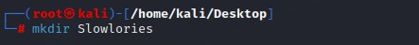

### Step 3:

Move to the directory that you have to create (Slowloris). cd Slowloris

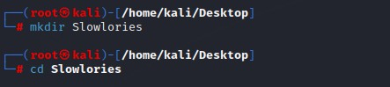

### Step 4:

Now you have to clone the Slowloris tool from Github so that you can install it on your Kali Linux machine. For that, you only have to type the following URL in your terminal within the Slowloris directory that you have created

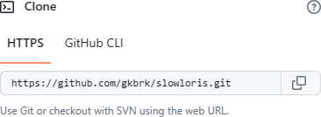

git clone <https://github.com/gkbrk/slowloris.git>

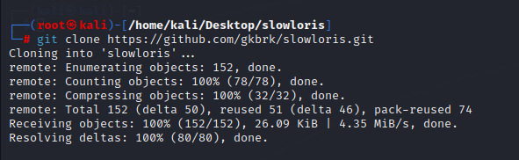

### Step 5:

Now go to the Action bar and click on split terminal vertically then you will see that the two- terminal screen has been open now.

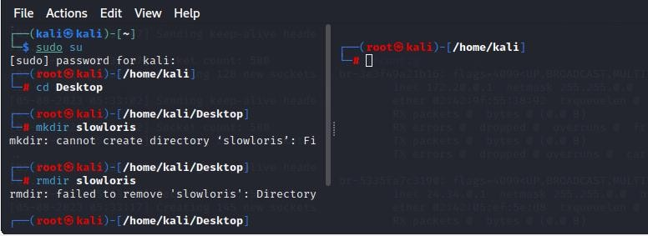

### Step 6:

Now you have to check the IP address of your machine to do that type of following command.

Ifconfig

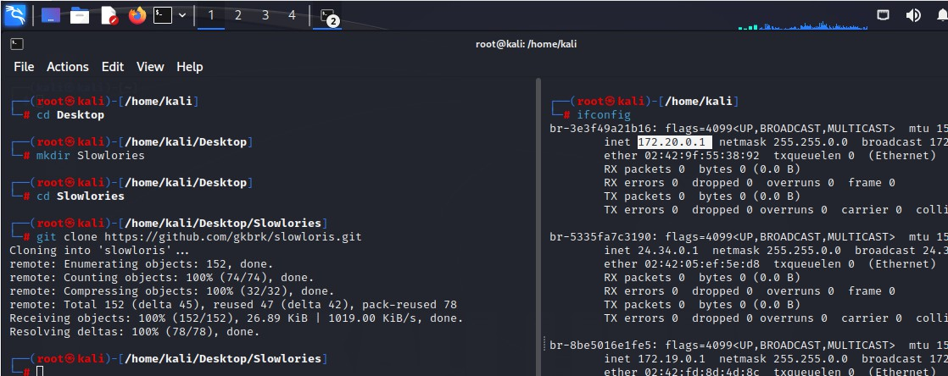

### Step 7:

As you can see, we got our IP address now it’s time to start the apache server, start the apache server using the following command

service apache2 start Service apache2 status

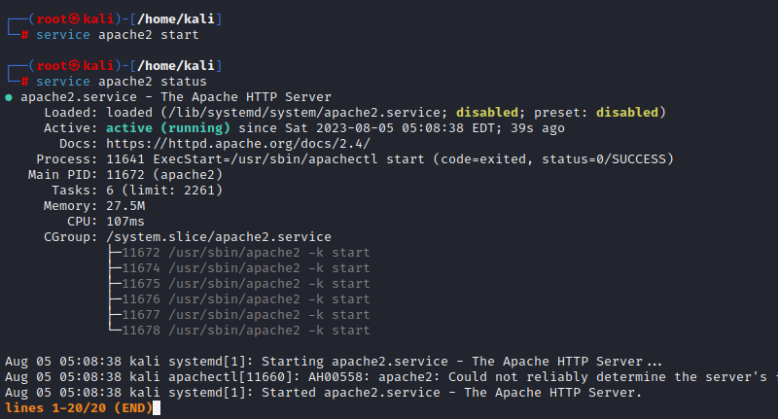

### Step 8:

Now we have to check the status of your server whether it is active or not so to check the status of your server run the following command.

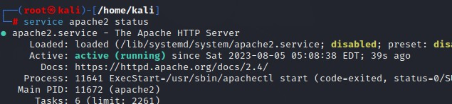

### Step 9:

We can see that our server is under active status it means is running properly, now come back to the first terminal, and to check permissions run the following command.

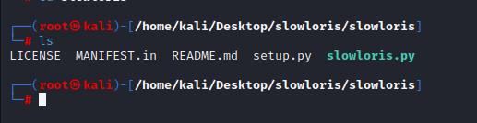

ls-l

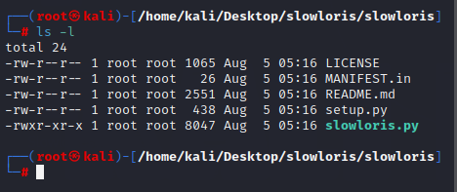

### Step 10:

Now it’s time to run the tool using the following command. python3 slowloris.py (your ip address) -s 500

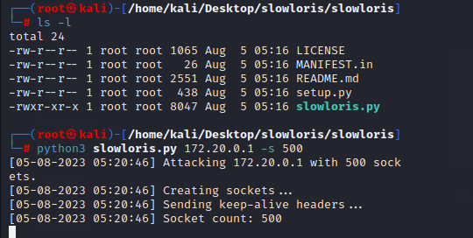

### Step 11:

You can see the tool has started attacking that particular IP address which we have given now to check whether its working or not go to your browser and on your URL bar type that IP address, and you will see the site is only loading and loading but not opening this is how Slowloris tool works.

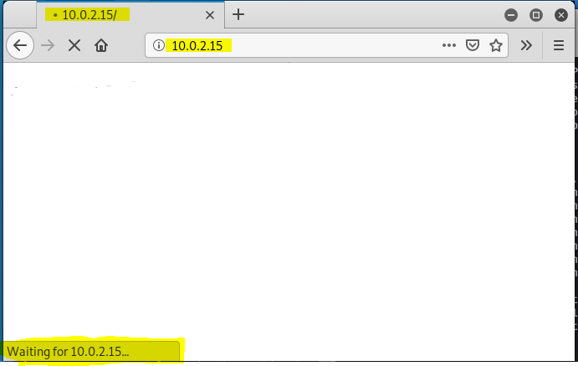

As you can see here the browser is waiting for an IP address because the browser is not able to load the page, this is because the denial-of-service attack is happening behind the browser using slowloris tool if you want to attack the live website you can attack using the domain name of that website instead of giving the IP address of the system to the slowloris tool. Slowloris tool will start attacking that particular domain however it’s a crime, and we do not promote such type of activity the tutorial was only for education purposes.

### Step 12:

Capturing network traffic using Wireshark.

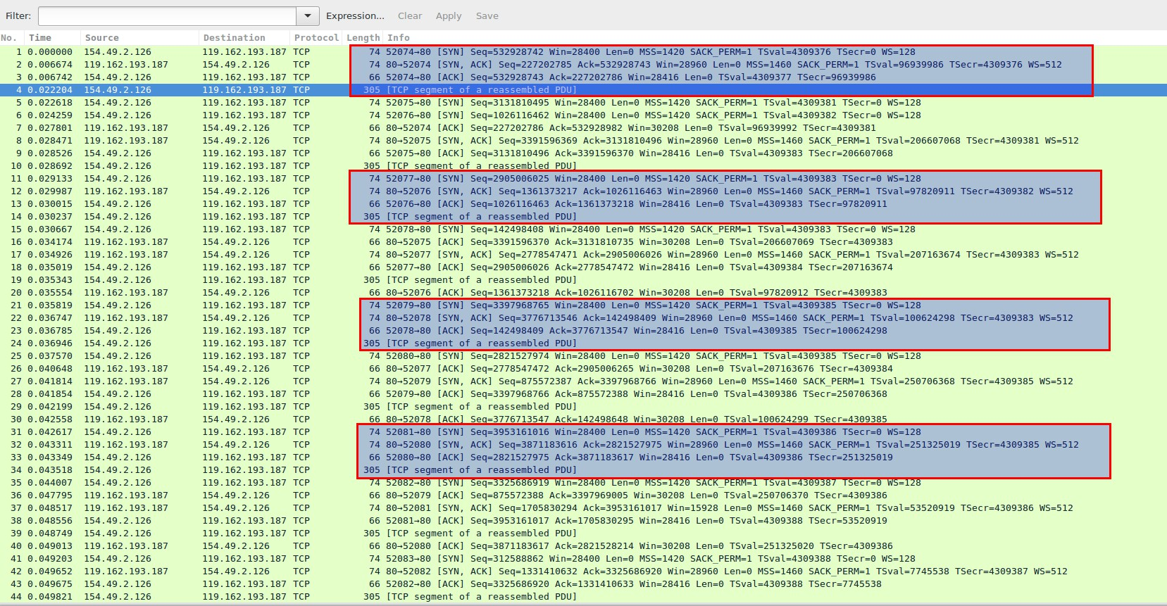

# CONCLUSION:

lab successfully provided hands-on experience in simulating a DoS attack using Slowloris, detecting such attacks using Wireshark, and exploring countermeasures to enhance network security.

**Experiment No: 11**

**Install IDS (Example Snort) and Study Logs**

# Aim:

Install IDS (snort) and monitor and detect potential security threats.

# Objective:

The purpose of this implementation is to set up and configure Snort, an open-source network intrusion detection system (NIDS), to monitor and detect potential security threats within our network infrastructure.

# Hardware/Software Required:

Kali Linux

# Theory:

SNORT is a powerful open-source Intrusion Detection System (IDS) and Intrusion Prevention System (IPS) that provides real-time network traffic analysis and data packet logging. SNORT uses a rule-based language that combines anomaly, protocol, and signature inspection methods to detect potentially malicious activity.

Using SNORT, network admins can spot denial-of-service (DoS) attacks and distributed DoS (DDoS) attacks, Common Gateway Interface (CGI) attacks, buffer overflows, and stealth port scans. SNORT creates a series of rules that define malicious network activity, identify malicious packets, and send alerts to users.

# Procedure:

### Step 1:

**Preparation:**

Identified the network segments where Snort deployment is needed.

Installed the chosen operating system and ensured it was up-to-date with the latest patches

### Step 2:

**Installing Snort:**

Installing the snort by using following commd sudo apt-get install snort -y

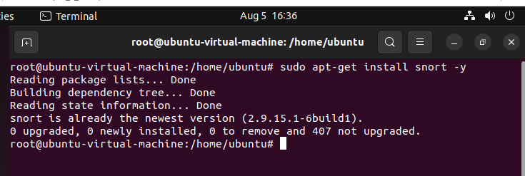

### Step 3:

Create the required files and directory cd /etc/snort

ls

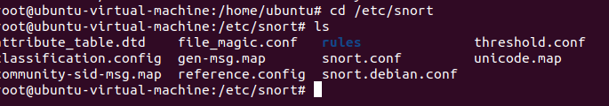

cd rules

ls

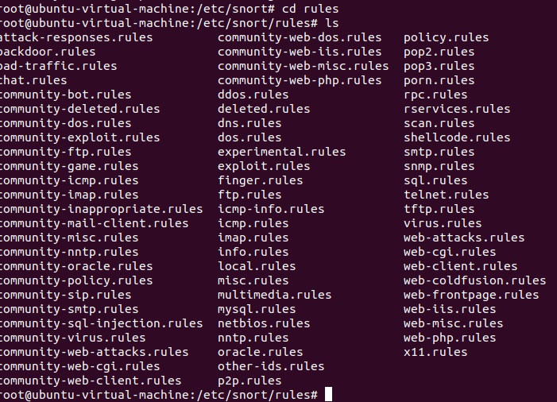

### Step 4:

Create the following snort.conf and rules files: nano local.rules

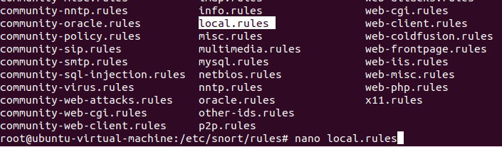

### Following is the structure of the alert:

<Rule Actions> <Protocol> <Source IP Address> <Source Port> <Direction Operator>

<Destination IP Address> <Destination > (rule options)

alert icmp $EXTERNAL_NET any -> $HOME_NET any (msg:”ping alert”; sid:5889; rev:1;) alert tcp any any -> $HOME_NET 21 (msg:”FTP attempt:”; sid:60001; rev:1;)

alert tcp any any -> $HOME_NET 22 (msg:”SSH attempt:”; sid:60002; rev:1;)

Table: Rule structure and example

|  |  |
| --- | --- |
| **Structure** | **Example** |
| Rule Actions | alert |
| Protocol | icmp |
| Source IP Address | any |
| Source Port | any |
| Direction Operator | -> |
| Destination IP Address | any |
| Destination Port | any |
| (rule options) | (msg:”ICMP Packet”; sid:5889; rev:1;) |

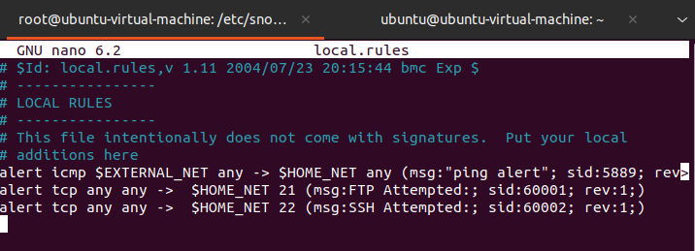

### Step 5:

Testing the command

snort -T -c /etc/snort/snort.conf

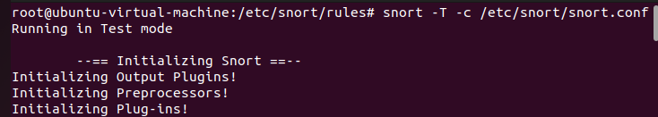

### Step 6:

Execute snort

Execute snort from command line, as mentioned below. snort -A console -c /etc/snort/snort.conf

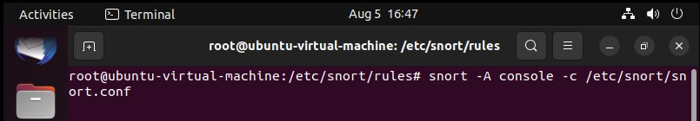

### Step 7:

Try pinging some IP from your machine, to check our ping rule. ping <ip address >

ftp <ip address> ssh <ip address>

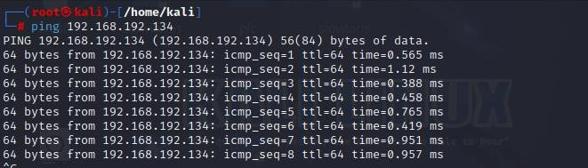

### Step 8:

Getting alert Message:

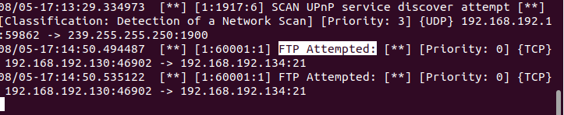

# Conclusion:

The successful implementation of Snort as our network intrusion detection system has ability to detect and respond to security threats. By continuously monitoring and updating the system, we are confident that Snort will continue to play a critical role in maintaining the security and integrity of our network environment.

**Experiment No: 12**

**Damn Vulnerable Web Application**

# Aim:

DVWA is a PHP/MySQL web application, whose main goal is to be an aid for security professionals to test their skills and tools in a legal environment.

# Objective:

we are using dvwa for installation and implementation process here

# Hardware/Software required:

Kali Linux, Mozilla Firefox

# Theory:

The Damn Vulnerable Web Application (DVWA) is a free and open-source web application that is designed to help security professionals and developers learn about common web application security vulnerabilities. DVWA is a PHP/MySQL web application that contains a wide range of vulnerabilities, including SQL injection, cross-site scripting (XSS), file upload, and insecure direct object references.

DVWA is a valuable tool for anyone who wants to learn about web application security. It can be used to test the skills of penetration testers, help web developers understand how to secure their applications, and teach students about web application security.

DVWA is easy to use. It can be installed on a local machine or on a cloud-based platform. Once it is installed, DVWA can be accessed through a web browser. The application has a user- friendly interface that makes it easy to find and exploit the vulnerabilities.

DVWA is a valuable resource for anyone who wants to learn about web application security. It is a free and open-source tool that is easy to use. DVWA can be used to test the skills of

penetration testers, help web developers understand how to secure their applications, and teach students about web application security.

# Procedure:

### Step 1:

First, we need to go to kali Linux, and then open Firefox. we need to search for dvwa installation.

### Step 2:

select the GitHub link which is shown at top

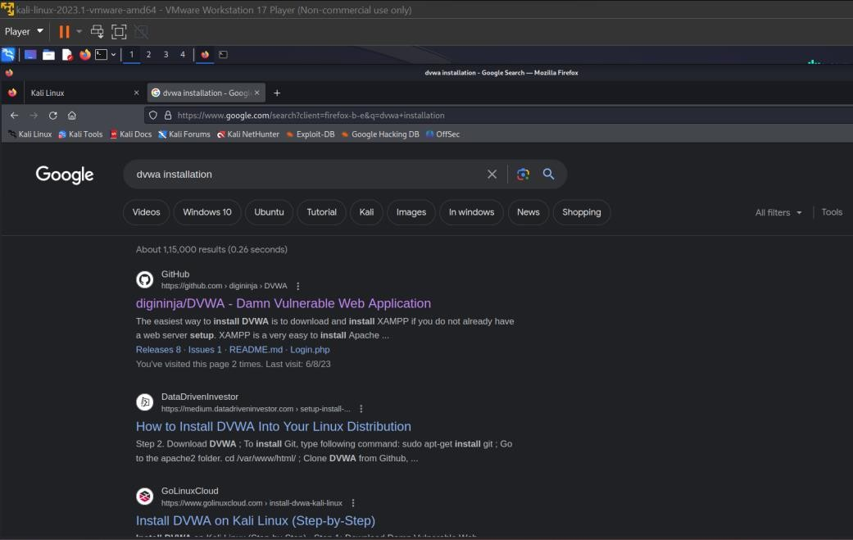

.

### Step 3:

We will copy the link address as shown below

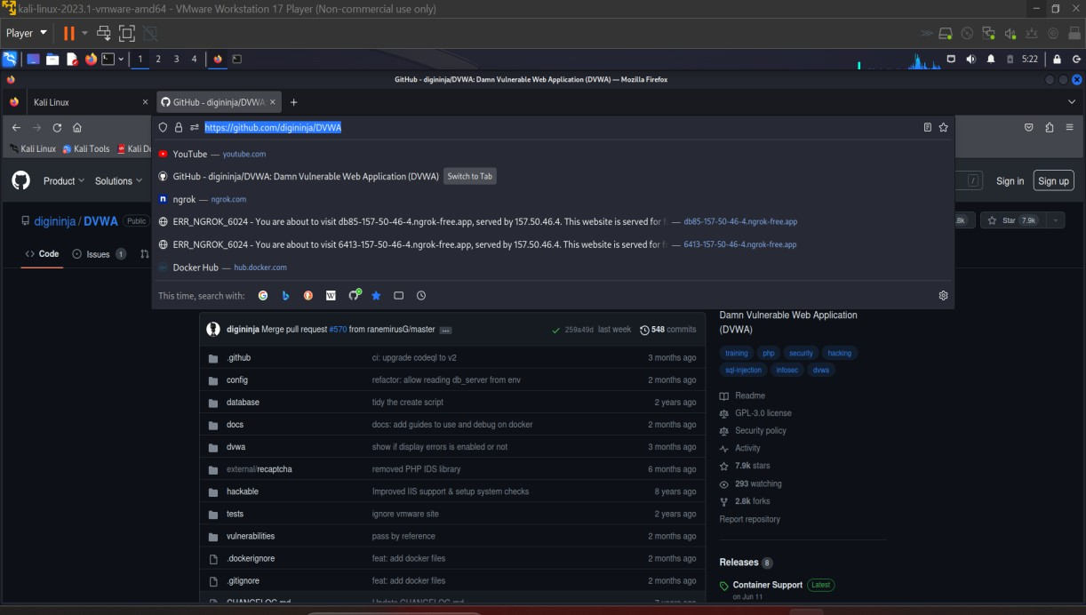

### Step 4:

Then we need to go to terminal in Linux and follow the following steps Cd var/www/html

Git clone https://github.com/digininja/DVWA.git

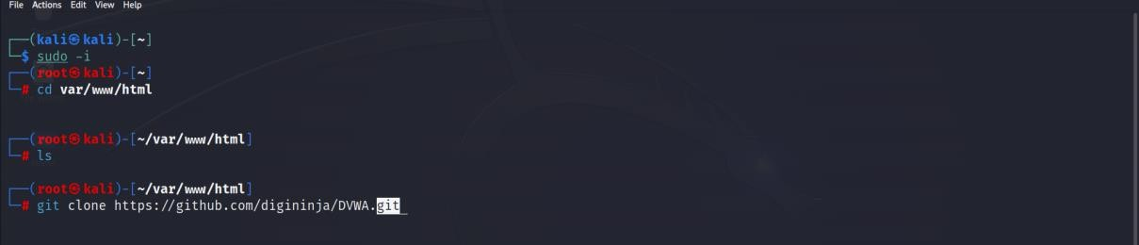

### Step 5:

Then we will git clone the following link We will get into dvwa

And then check what all the files present there Cd DVWA

ls

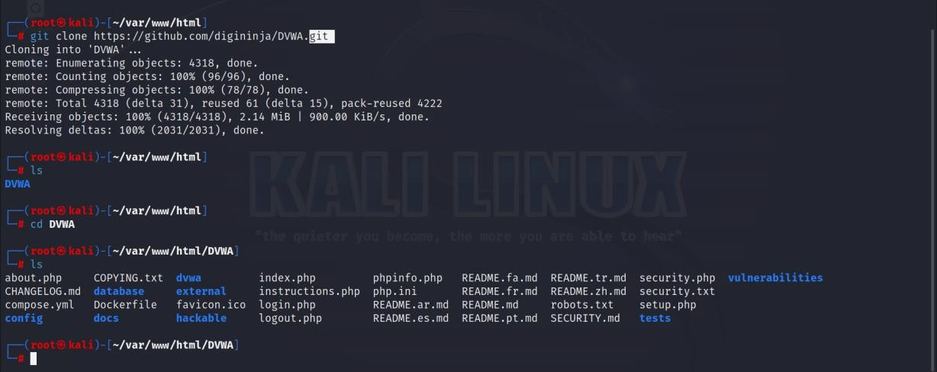

### Step 6:

Then we will come out of that directory and then we will Give a permission to that directory

We can see the difference after giving the permission Chmod -R 777 DVWA

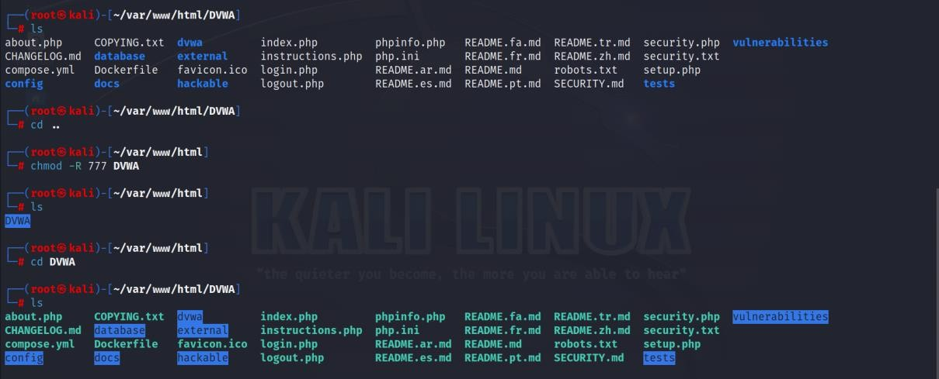

### Step 7:

Then we will change the directory to config And cp to config file present there

After that we need to install gedit if its not installed Then write the gedit command for following file

cd config

cp config.inc.php.dist config.inc.php gedit config.inc.php

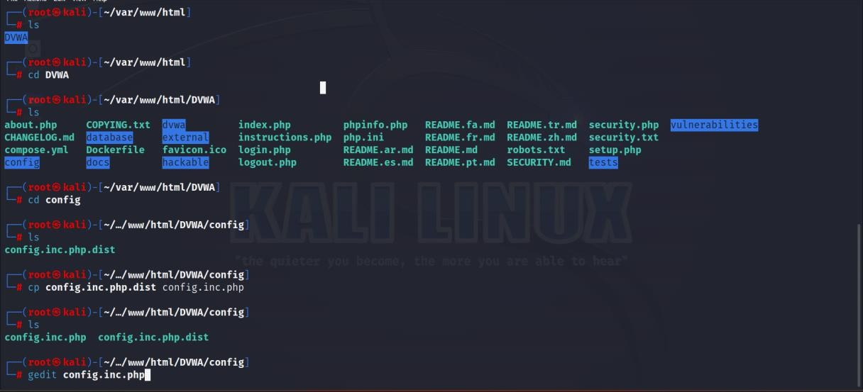

### Step 8:

Then we will change the user name and passwods as shown below.

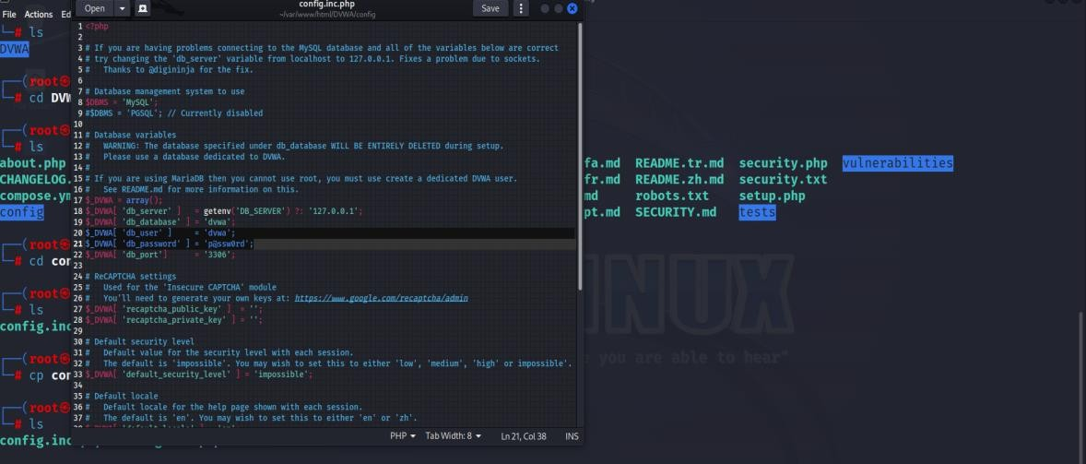

We can see we have changed the password from special character to normal one

User name=user Password=pass

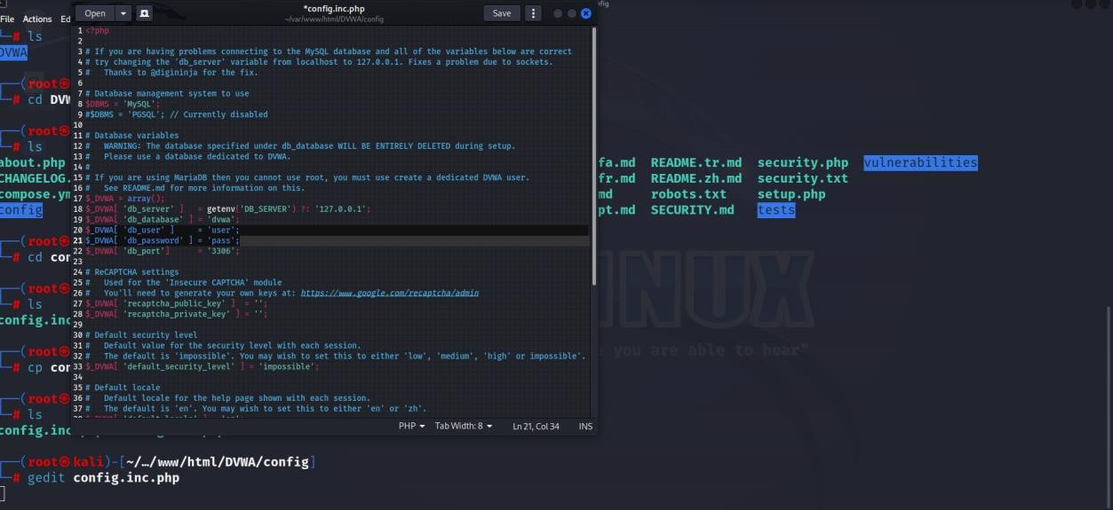

### Step 9:

After that we come out of all directories and we will run the below command Then we can in status of mysql both are disabled

cd

systemctl status mysql

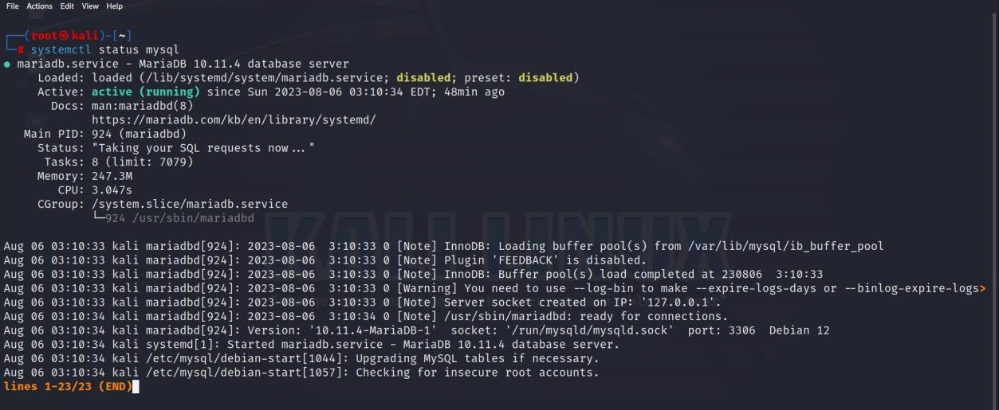

### Step 10:

We will change one of them to enabled, by below command Systemctl enable mysql

systemctl status mysql

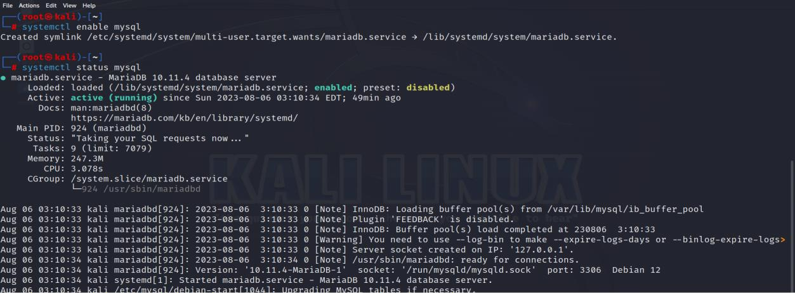

### Step 11:

Then we will start the services of mysql Service mysql start



### Step 12:

Then we will check the status of mysql by below command systemctl status mysql

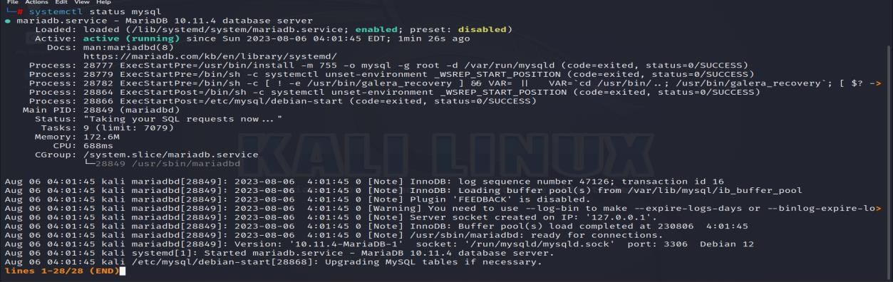

### Step 13:

After that we have get into root of mysql Sudo mysql -u root -p

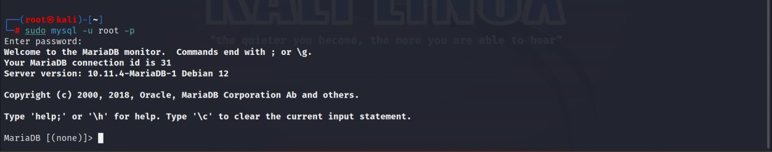

We will not enter any password we will just click enter

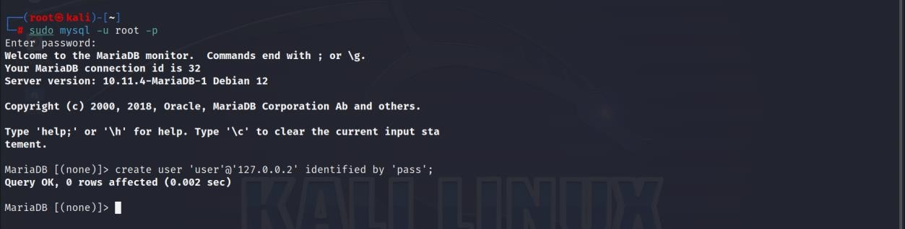

### Step 14:

And then after entering into that we will write the below command create user ‘user’@‘127.0.0.2’ identified by ‘pass’;

grant all privileges on dvwa.* to ‘user’@‘127.0.0.2’ identified by ‘pass’; exit

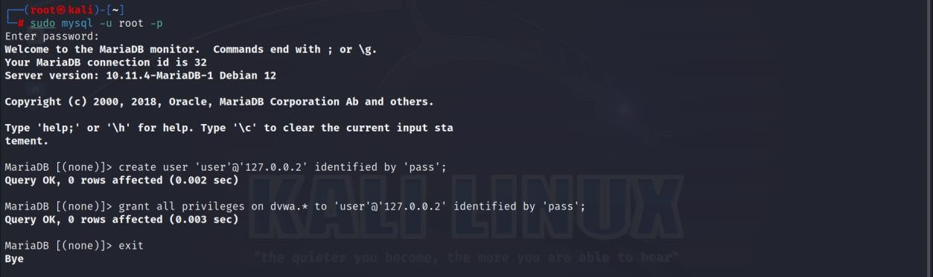

### Step 15:

After that we will get into thse directory And then into the present version

And we will see apache2 cli and etc We will get into apache2

cd /etc/php cd 8.1

cd apache2 gedit php.ini

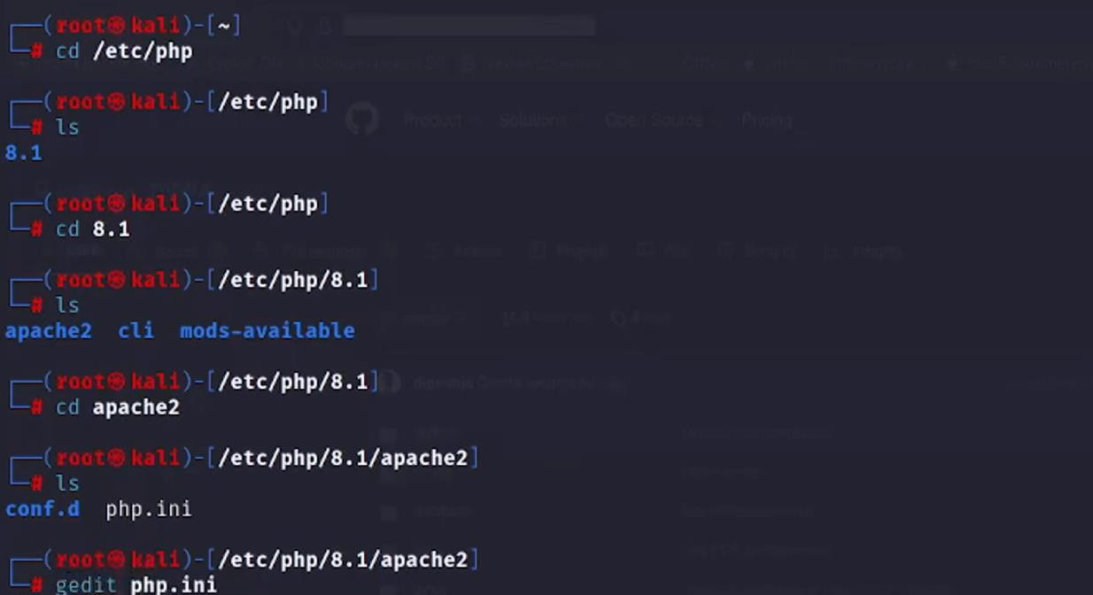

### Step 16:

Then we will use gedit for phpini file

In the line of 865 we have a command off, we will turn it as on

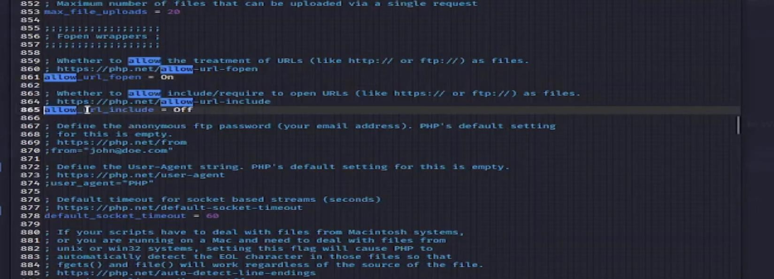

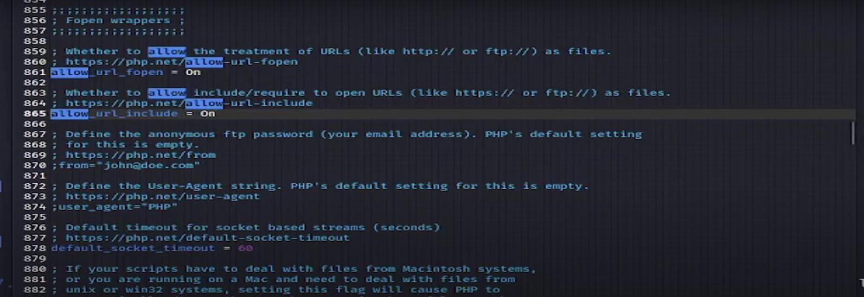

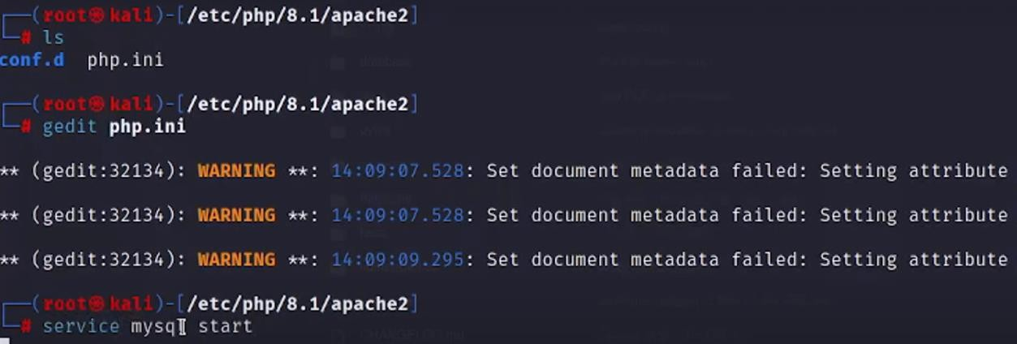

### Step 17:

Then we will start apache2 And check apache2 status

Service apache2 start Systemctl status apache2

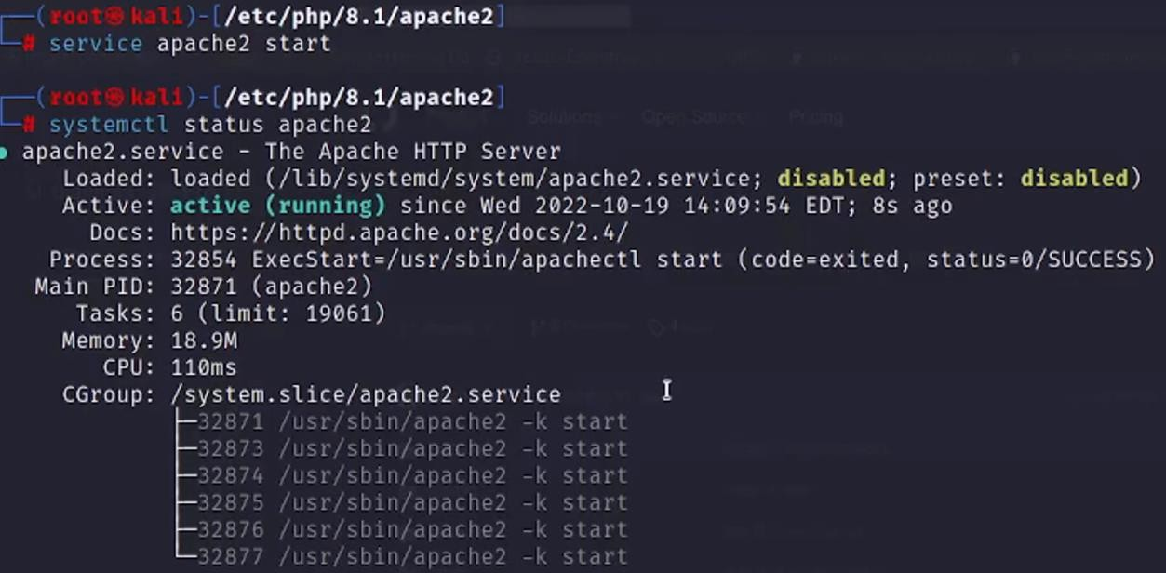

### Step 18:

Then we will go to firefox and browse the ip Which is shown below

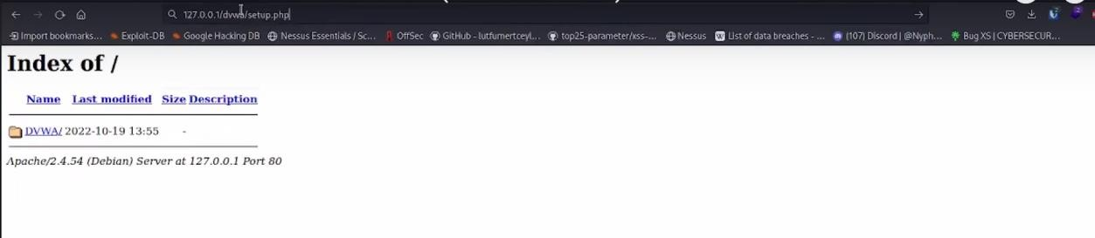

We will get a webpage like this

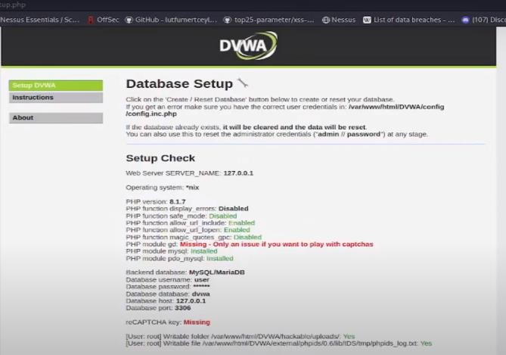

At the bottom we will click on create

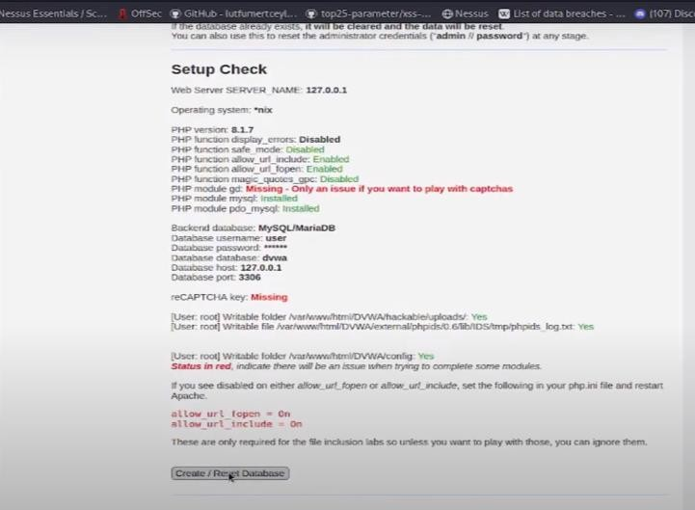

And we will enter our user name and password which we have entered before

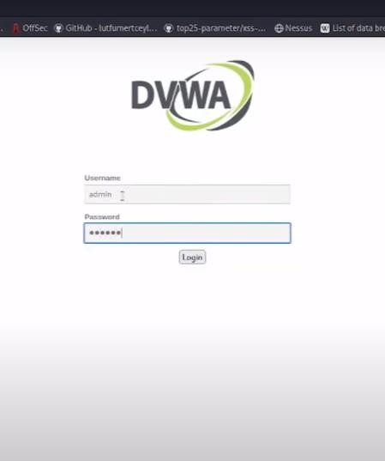

And finally, dvwa was set up

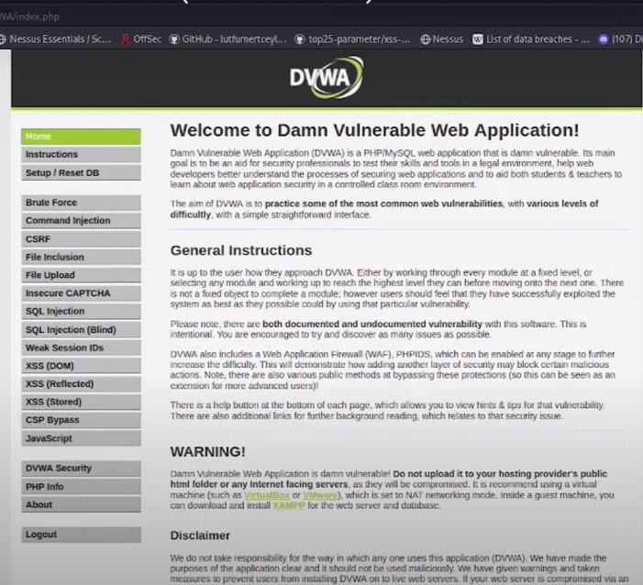

# Conclusion:

DVWA experiment serves as a stark reminder of the importance of proactively addressing security issues, fostering a culture of security awareness, and continuously improving the resilience of web applications against potential threats. By doing so, we can better protect sensitive data, uphold user privacy, and safeguard the overall integrity of web-based systems.

**Experiment No: 13**

**Creating a Docker Image for your Application & Pull Docker Image from Docker Hub and Run it.**

# Aim:

1. Creating a Docker Image for your Application Write a Docker file for your application. Build the image with docker build command. Host your Docker image on a registry.

Pull and run the image on the target machine.

1. Pull Docker Image from Docker Hub and Run it.

# Objectives:

Objectives of this module to learn about Docker image creation & Push that Image to Docker Hub and Pull Docker Image from Docker Hub & run it.

# Outcomes:

Build the image with docker build command & host builded Docker Image on a registry. Pull Docker Image from Docker Hub and Run it.

**Theory:**

**Docker** Image is an executable package of software that includes everything needed to run an application. This image informs how a container should instantiate, determining which software components will run and how.

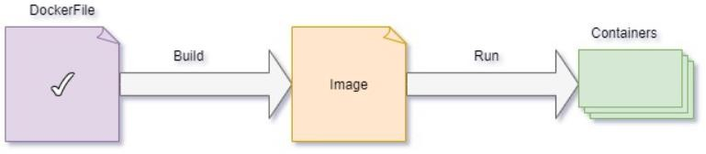

# Uses of Docker Images:

* 1. We can easily and effectively run the containers with the aid of docker images.
  2. All the code, configuration settings, environmental variables, libraries, and runtime are included in a Docker image.
  3. Docker images are platform-independent.
  4. Layers are the building blocks of an image.
  5. With When using the build command, the user has the option of completely starting from scratch or using an existing image for the first layer.

# Procedure

### Creating Docker Image:

**Step 1:**

Install Docker & note docker version. apt install docker.io

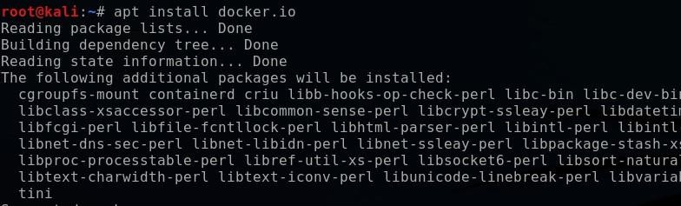



### Step 2:

Make a directory to store docker & move inside the docker. mkdir docker

cd docker

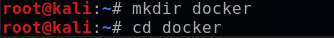

### Step 3:

Create a file using ‘nano’ command & write a program on it. E.g., nano square.py

To display the program use ‘cat’ command. i.e. cat square.py

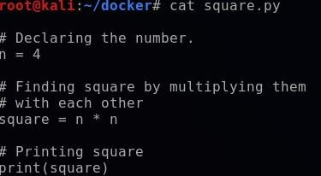

### Step 4:

Create a docker file using ‘touch’ command & make list using ‘ls’ command.

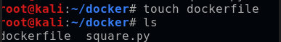

### Step 5:

Write a code in docker file. To display the code use ‘cat’ command.

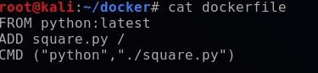

### Step 6:

To list Docker Images in your local Docker repository, use this command. i.e. docker images



### Step 7:

To list all the Docker processes actively running & stopped, use the command as docker ps -a



### Step 8:

To build docker image use this command. i.e.

docker image build -t < image name >:< tag > /root/docker

E.g. docker image build -t pythonsquare:1.0 /root/docker

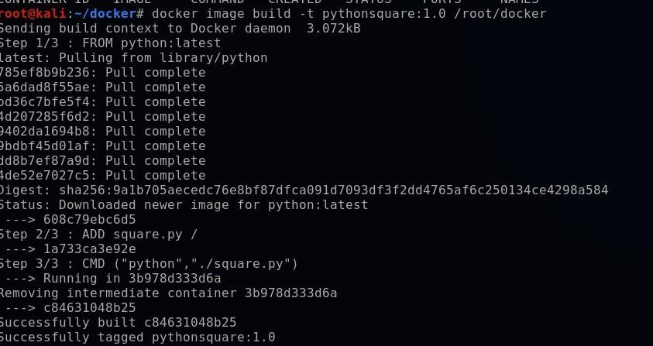

### Step 9:

After build the image, to list Docker Images in your local Docker repository, use this command. i.e. docker images

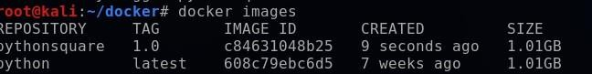

### Step 10:

To build docker image in host use this command, i.e.

docker image build -t < host name >/< image name >:< tag > /root/docker

E.g. docker image build -t shreyahegde123/pythonsquare:1.0 /root/docker

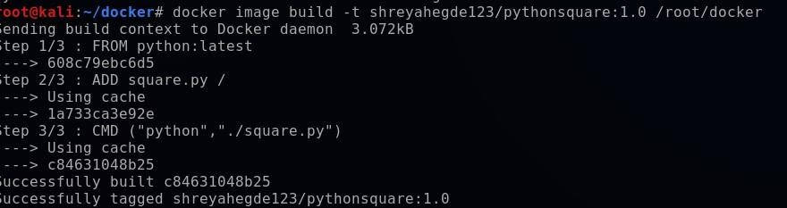

### Step 11:

Now login with your Docker ID to push & pull images from Docker Hub. For login, use this command i.e. docker login

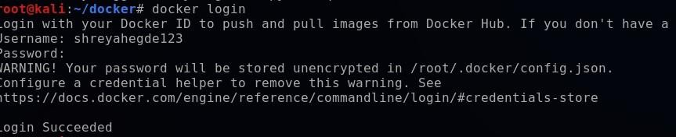

### Step 12:

Now using docker tag command make sure builded image is locally available. For that use the command as,

docker tag < image name > < host name >/< image name >:< tag >

E.g. docker tag pythonsquare:1.0 shreyahegde123/pythonsquare:1.0



### Step 13:

Then push docker image to the Docker Hub using the command, docker push < host name >/< image name >:< tag >

E.g. docker push shreyahegde123/pythonsquare:1.0

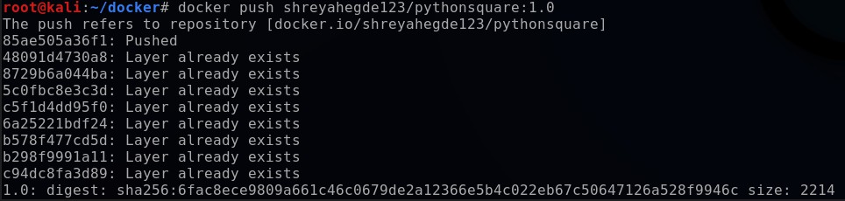

### Step 14:

After image is pushed to Docker Hub, go to Docker Hub and login with Docker ID & password. In Repository, we can able to see the pushed image.

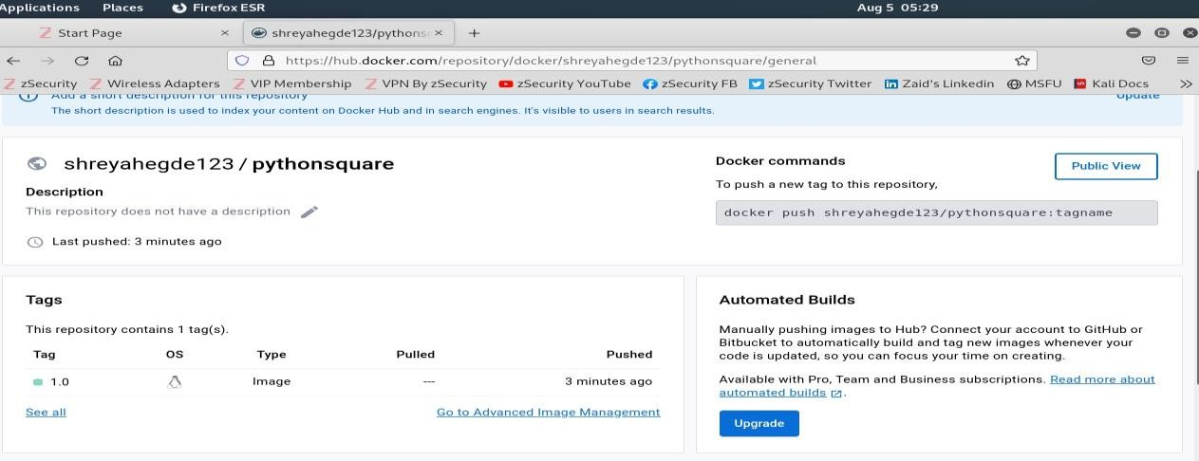

### Step 15:

Now pull the created image from Docker Hub, use the command as docker pull <docker hub username>/pythonsquare:1.0

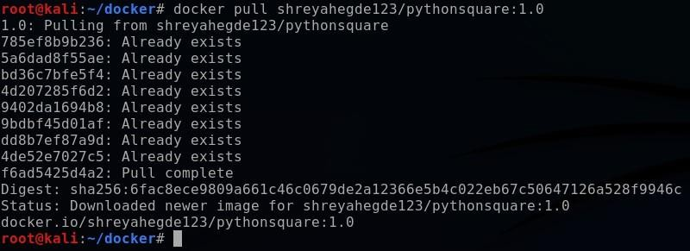

# Pull Docker Image from Docker Hub and Run it. Procedure:

### Step 1:

To pull image from Docker Hub, use the command as docker pull < image name >

E.g. docker pull ubuntu

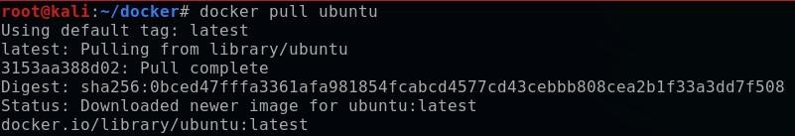

### Step 2:

After pull the image from Docker Hub, to list Docker Images in your local Docker repository, use this command. i.e. docker images

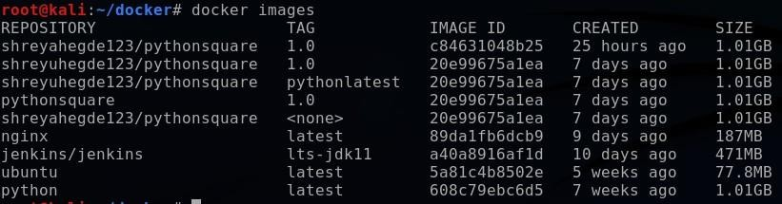

### Step 3:

Now to run the docker image, use the command as docker run < image name >

E.g. docker run ubuntu



### Step 4:

To list all the Docker processes actively running & stopped, docker ps -a

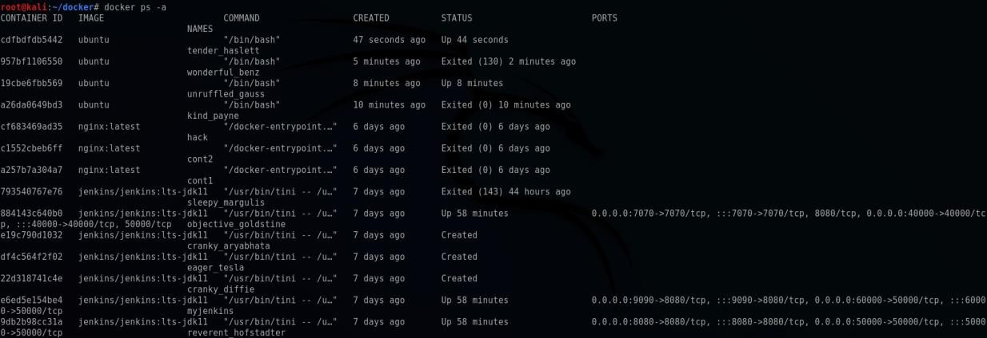

### Step 5:

To start run the docker image, use command as docker start < container ID >



### Step 6:

To get inside the running image, use command as docker exec -itd < container ID > /bin/bash docker exec -it < container ID > /bin/bash

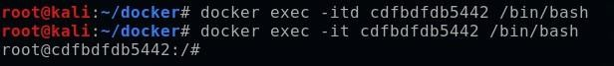

# Conclusion:

1. Successfully Created a Docker Image for our Application and also succeeded in below instructions.
   * Write a Dockerfile for your application.
   * Build the image with docker build command.
   * Host your Docker image on a registry.
   * Pull and run the image on the target machine.
2. Successfully Pulled Docker Image from Docker Hub and Runned that.

**Experiment No: 14**

**Create & Mounting Volumes into a Docker container in a Dockerized Jenkins job.**

# Aim:

Create & Mounting Volumes into a Docker container in a Dockerized Jenkins job.

# Objectives:

Objectives of this module to learn about Docker volume creation & Mounting volumes into a Docker container in a Dockerized Jenkins job.

# Theory:

A Docker volume is an independent file system entirely managed by Docker and exists as a normal file or directory on the host, where data is persisted.

# Uses of Docker Volume:

1. Volumes are easier to back up or migrate than bind mounts.
2. You can manage volumes using Docker CLI commands or the Docker API.
3. Volumes work on both Linux and Windows containers.
4. Volumes can be more safely shared among multiple containers.
5. Volume drivers let you store volumes on remote hosts or cloud providers, to encrypt the contents of volumes, or to add other functionality.
6. New volumes can have their content pre-populated by a container.

# Creating Docker Volume: Procedure:

### Step 1:

Install Docker & note docker version.



### Step 2:

Make a directory to store docker & move inside the docker. mkdir docker

cd docker



### Step 3:

Now create Docker volume using this command. i.e. docker volume create miivol

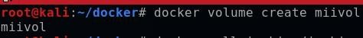

### Step 4:

Now pull the Jenkins image, using the command as

docker pull jenkins/jenkins:lts-jdk11

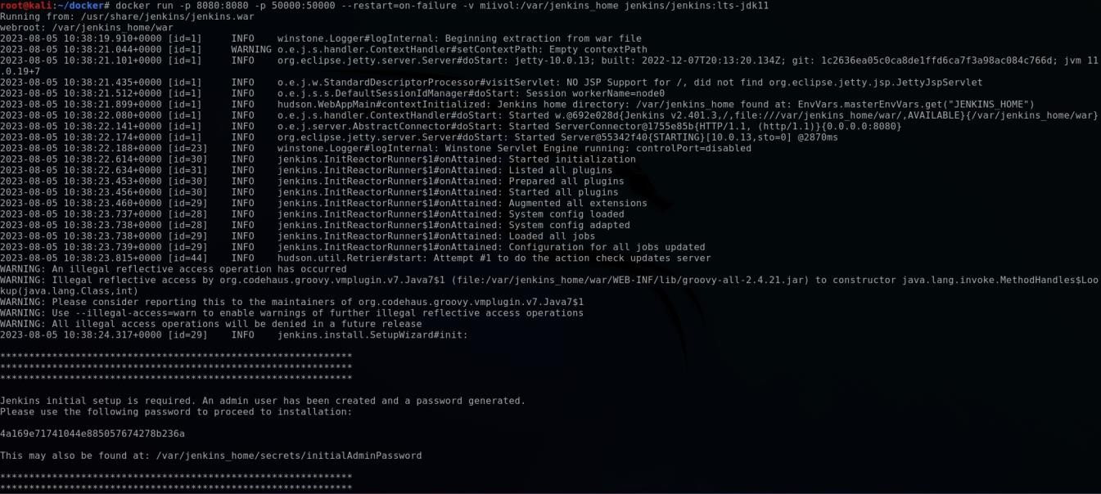

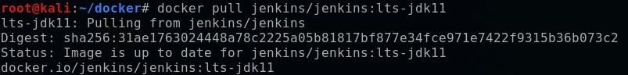

### Step 5:

Now run the image use the command as,

docker run -p 8080:8080 -p 50000:50000 –restart=on-failure -v miivol:/var/jenkins_home jenkins/jenkins:lts-jdk11

A password will be generated.

### Step 6:

Next go to browser, type localhost:8080, a page will be opened

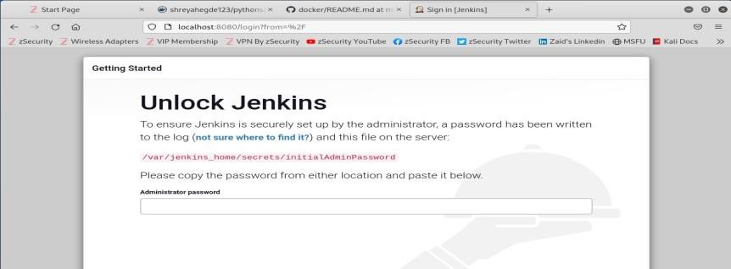

Using generated password, login.

### Step 7:

After that a page will be displayed as below,

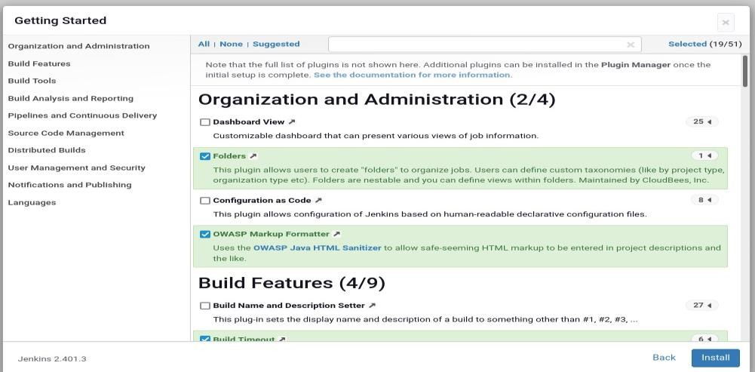

Click on none & continue.

### Step 8:

After that a page will be opened. By giving username & password create account in Jenkins.

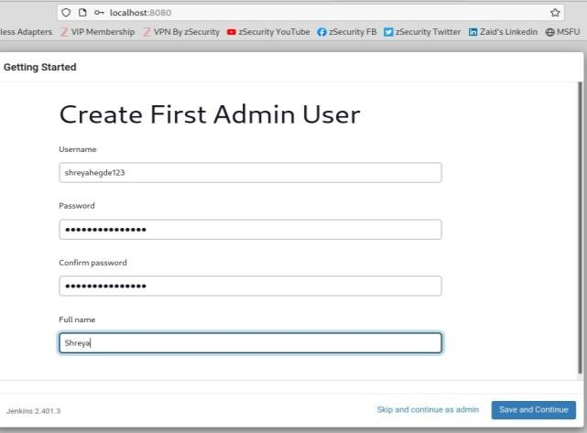

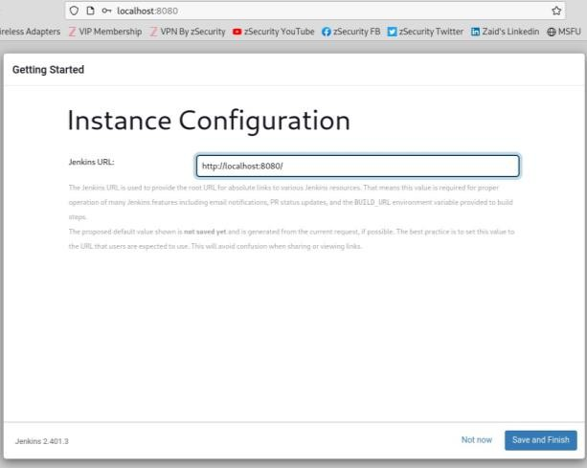

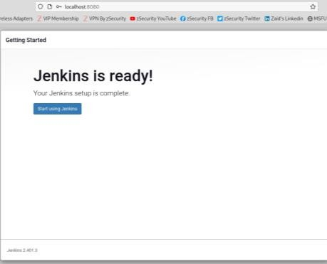

### Step 9:

After creating account in jenkins, a page will be opened like that,

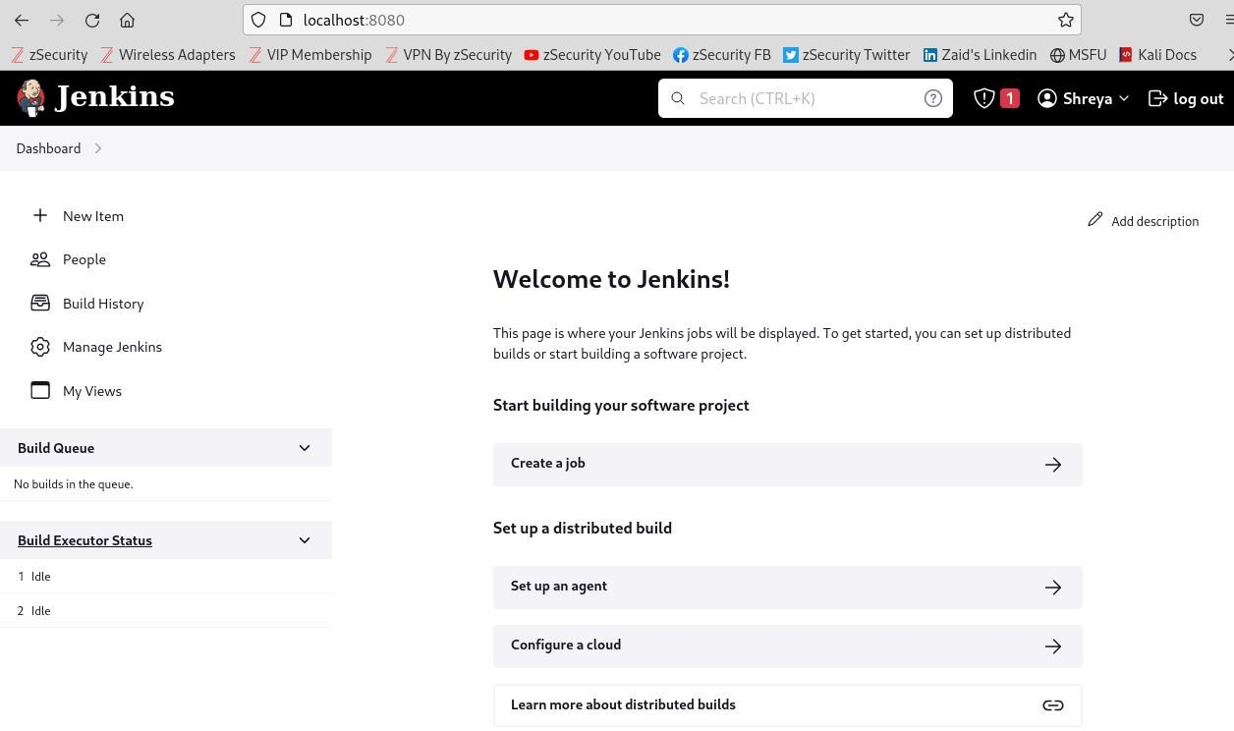

In which, click on Create a job.

### Step 10:

After selecting Create a job, a page will be displayed

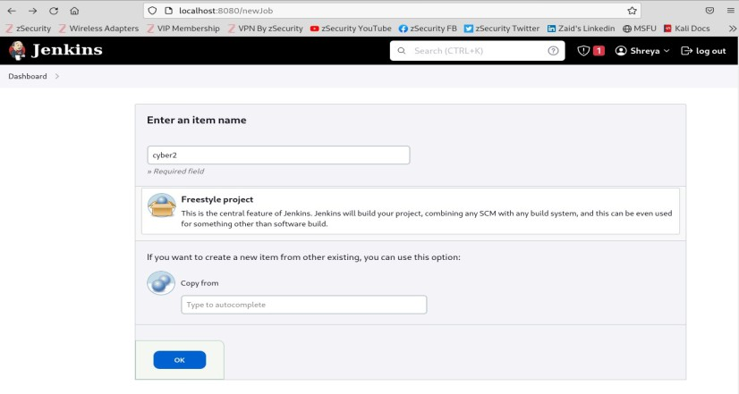

In that, enter the item name, e.g., cyber2 and click on ok.

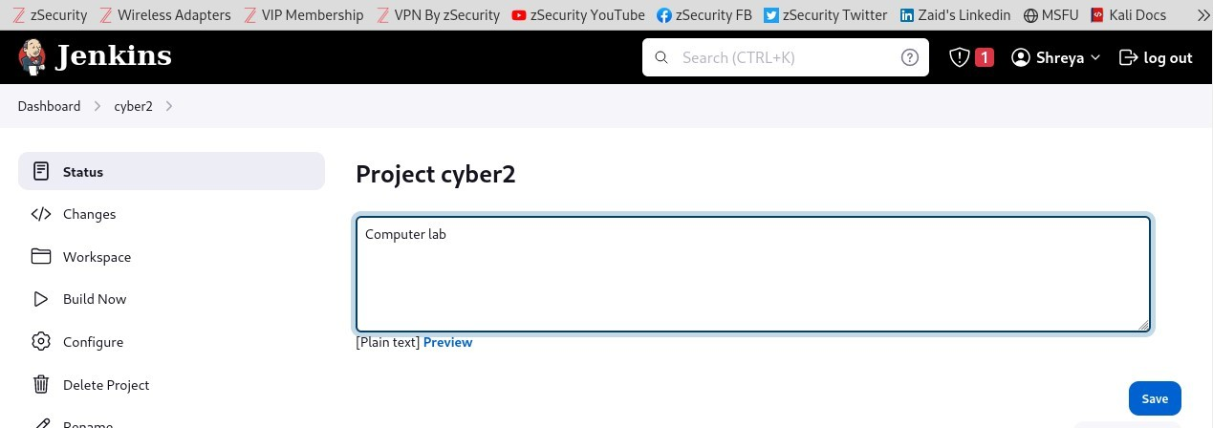

### Step 11:

After that, created volume will be shown as below,

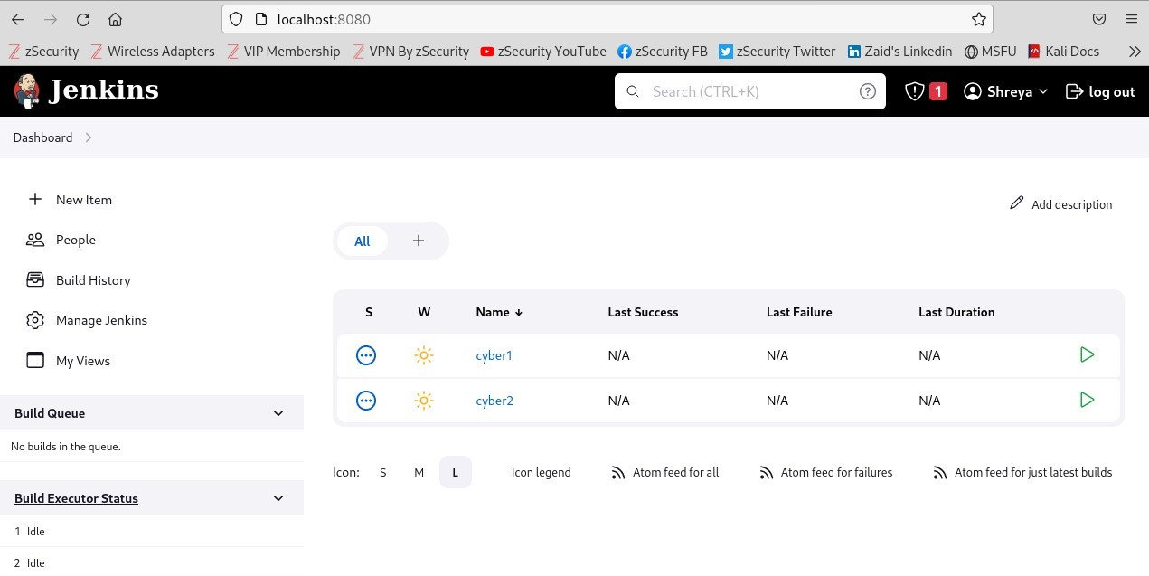

# Step 12:

Now once again run the docker image with different port number, the command will be as follows,

docker run -p 7070:8080 -p 30000:50000 –restart=on-failure -v miivol:/var/jenkins_home jenkins/jenkins:lts-jdk11

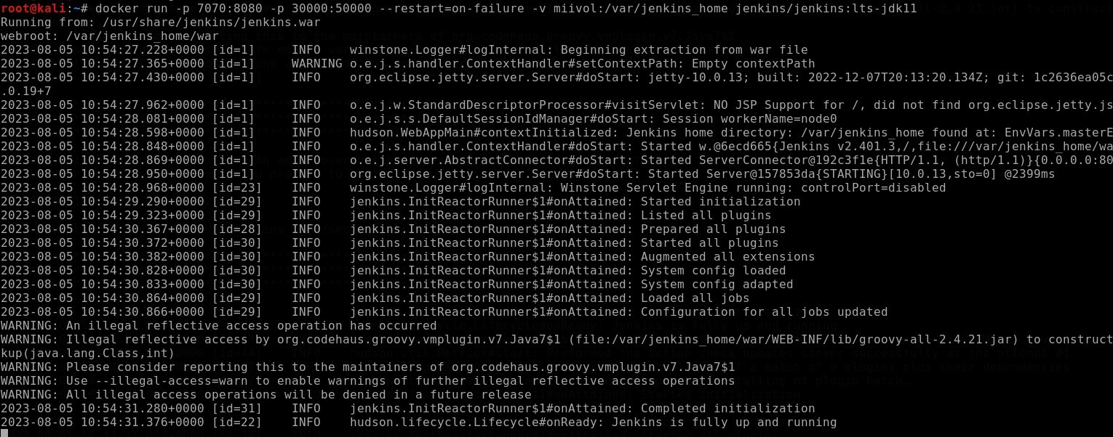

### Step 13:

Now go to browser, type localhost:7070, then a Jenkins sign in page will be displayed. Enter the credentials as given to the Jenkins account and sign in.

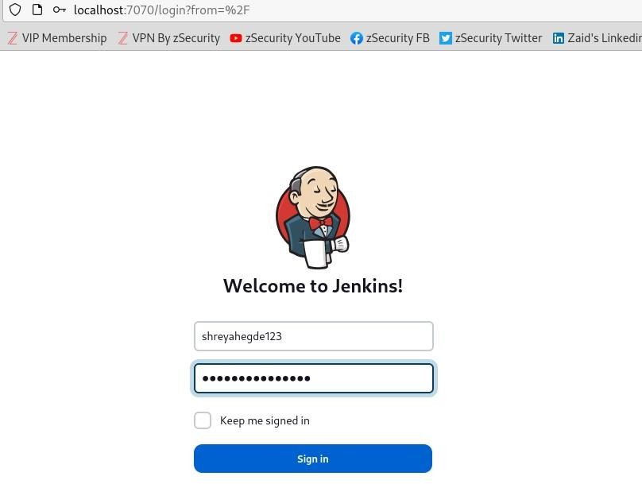

### Step 14:

After sign in to Jenkins, a page will be open; which contains the information about already created volumes as shown for the port 8080. i.e.

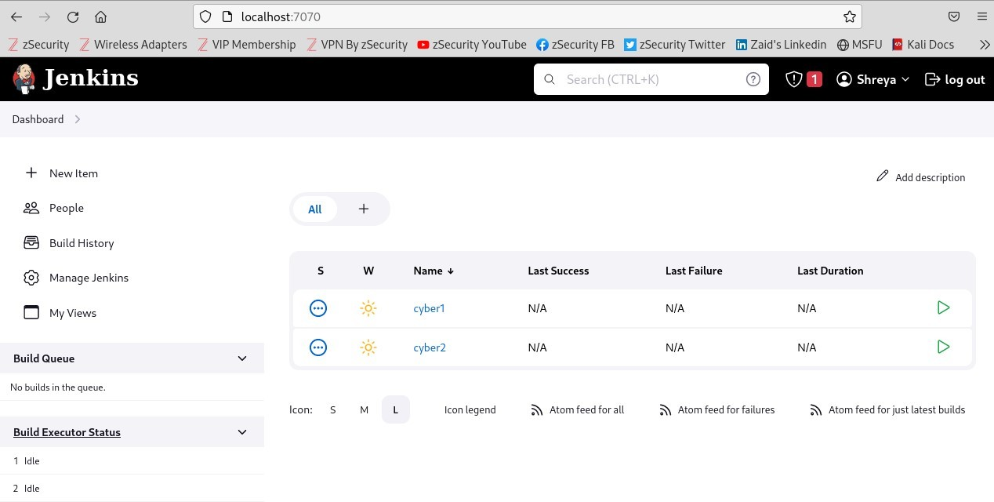

It’s a clear indication of created volume is mounted.

# Conclusion:

Successfully a Docker volume is Created & Mounted that Volume into a Docker container in a Dockerized Jenkins job.

**Experiment No: 15**

**Creating a Network in Docker and Connecting a Container to that Network**

# Aim:

To Create a Network in Docker and Connecting a Container to that Network.

# Objectives:

Objectives of this module to learn about how to create Network in Docker and how to Connect a Container to created Network.

# Theory:

For Docker containers to communicate with each other and the outside world via the host machine, there has to be a layer of networking involved. Docker supports different types of networks, each fit for certain use cases.

Docker comes with network drivers geared towards different use cases. The most common network types being: **bridge**, overlay, and macvlan.

Bridge Networks

Bridge networking is the most common network type. It is limited to containers within a single host running the Docker engine. Bridge networks are easy to create, manage and troubleshoot.

Overlay Networks

An overlay network uses software virtualization to create additional layers of network abstraction running on top of a physical network. In Docker, an overlay network driver is used for multi-host network communication.

Macvlan Networks

The macvlan driver is used to connect Docker containers directly to the host network interfaces through layer 2 segmentation. No use of port mapping or network address translation (NAT) is needed and containers can be assigned a public IP address which is accessible from the outside world.

# Creating two Containers and bridge those Containers: Procedure:

### Step 1:

Install Docker & note docker version.



### Step 2:

Make a directory to store docker & move inside the docker. mkdir docker

cd docker



### Step 3:

List the networks in docker using the command as, docker network ls

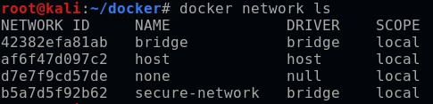

### Step 4:

To start your Nginx Docker container, run this command i.e. docker run -d --name cont5 nginx:latest



### Step 5:

To get inside the container, use the command as, docker exec -it cont5 /bin/bash

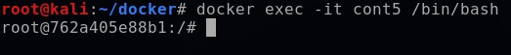

### Step 6:

Now update, using the command ‘apt update’

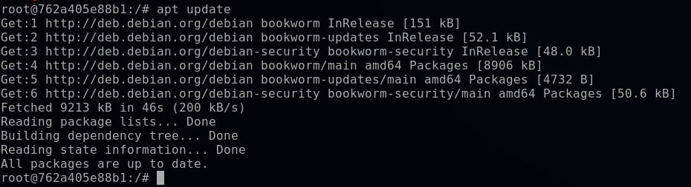

### Step7:

Ater updating the OS run following command to install the packages: apt-get install iputils-ping

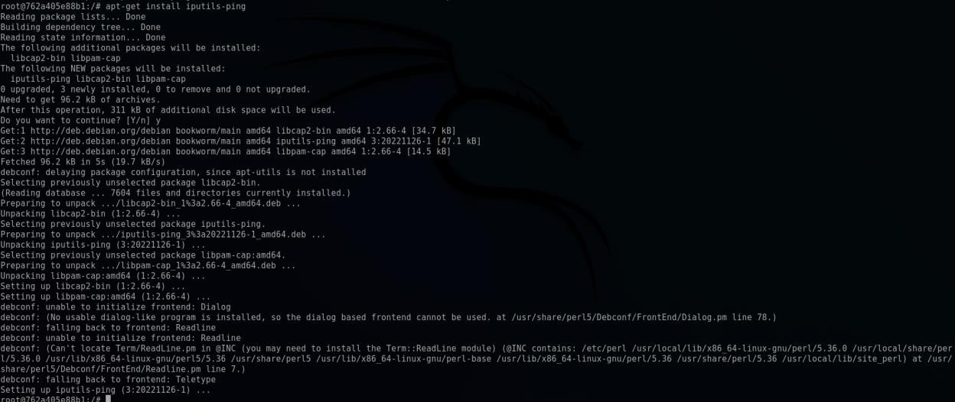

### Step 8:

To get all the details about cont5, use the command as, docker inspect cont5 & note down the IP address.

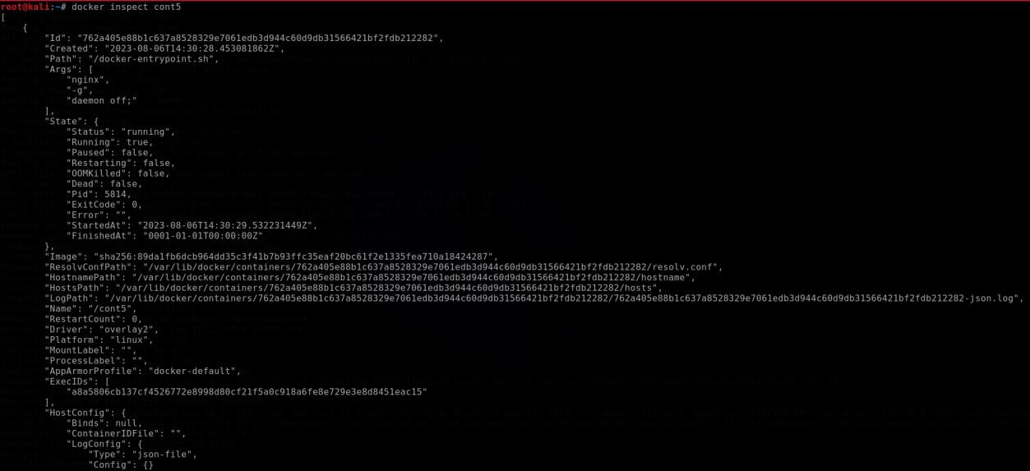

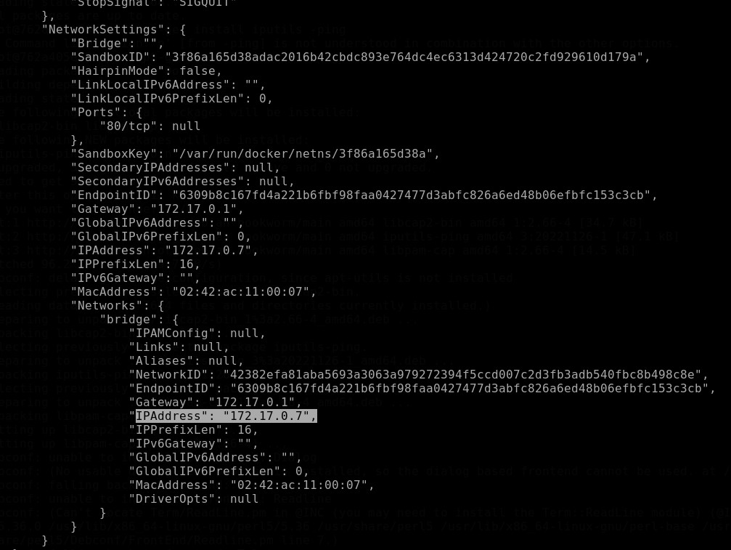

### Step 9:

To start another Nginx Docker container, run this command i.e. docker run -d --name cont6 nginx:latest

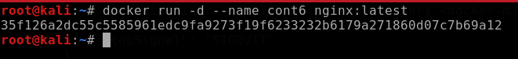

### Step 10:

To get inside the container, use the command as, docker exec -it cont6 /bin/bash

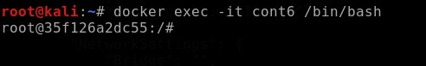

### Step 11:

Now update, using the command ‘apt update’

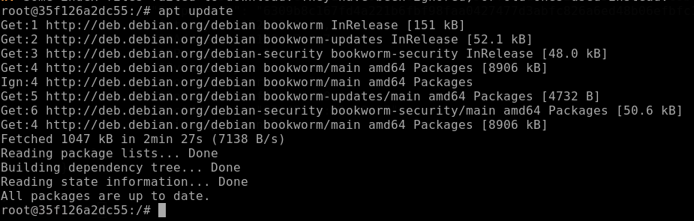

### Step 12:

Ater updating the OS run following command to install the packages: apt-get install iputils-ping

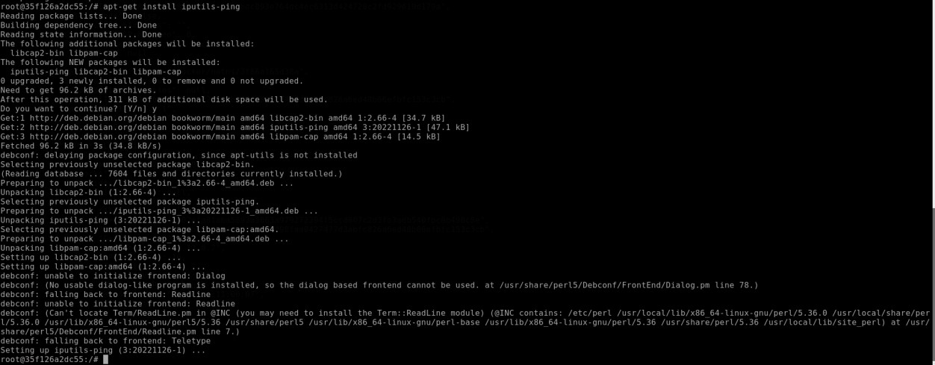

### Step 13:

To get all the details about cont6, use the command as, docker inspect cont5 & note down the IP address.

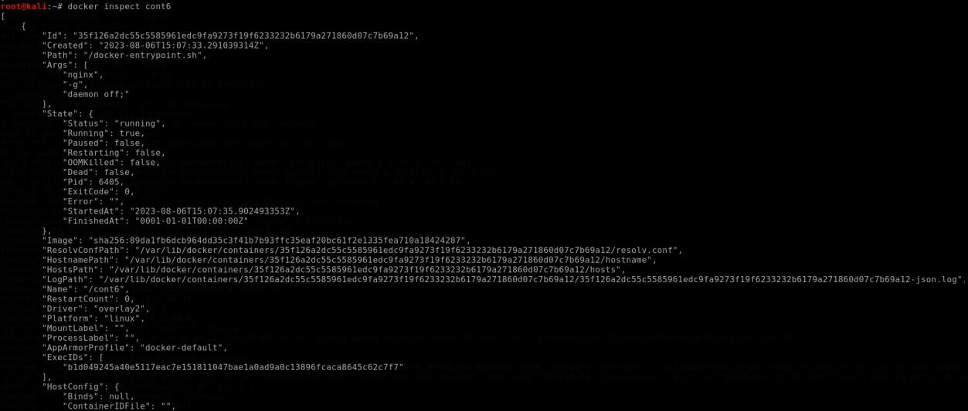

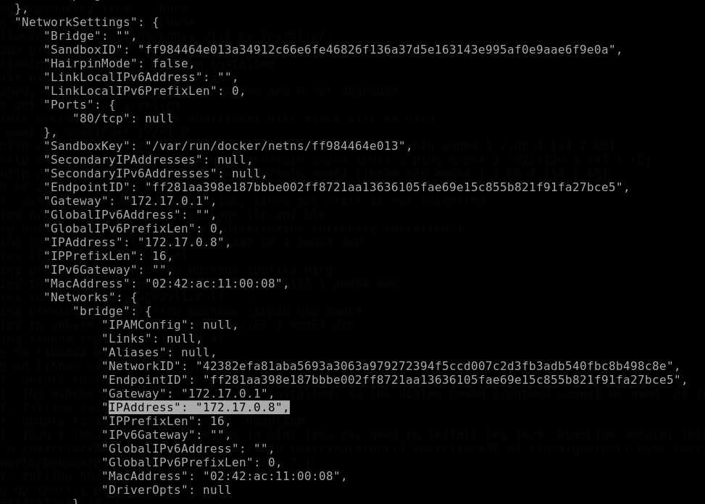

### Step 14:

Now ping cont5 IP address in cont6

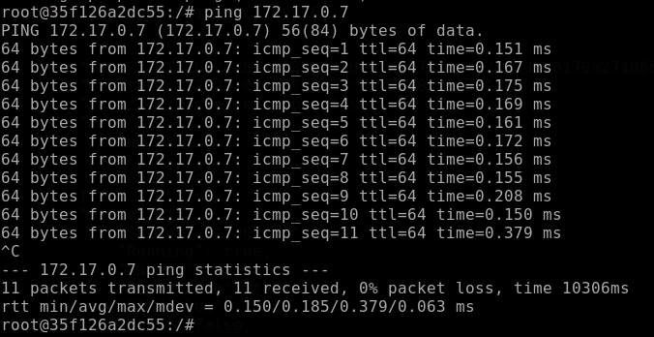

Ping cont6 IP address in cont5



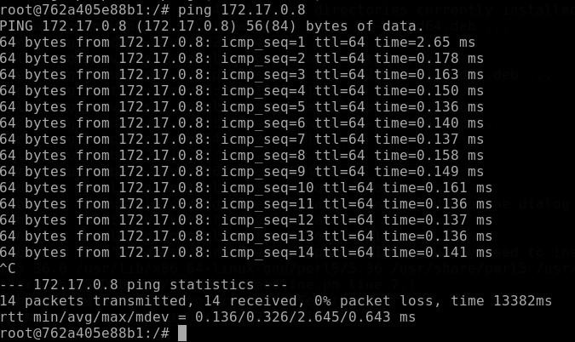

Both Containers allows to ping. It’s clearly indicating that both containers are become bridged.

# Creating Network: Procedure:

### Step 1:

Create a network using command as,

docker network create secure-network1

### Step 2:

List all the networks using ‘ls’ command i.e. docker network ls

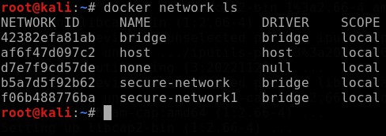



### Step 3:

Now run the created network using command as,

docker run -d –name cyber –network=secure-network1 nginx:latest

### Step 4:

To get all the details about this created network, use the command as docker inspect cyber & note the IP address.

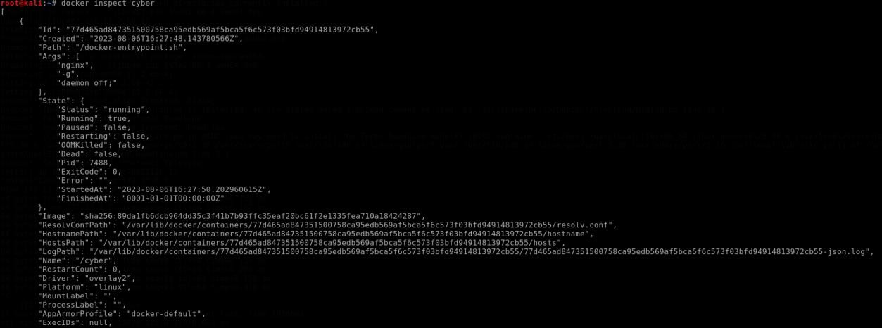

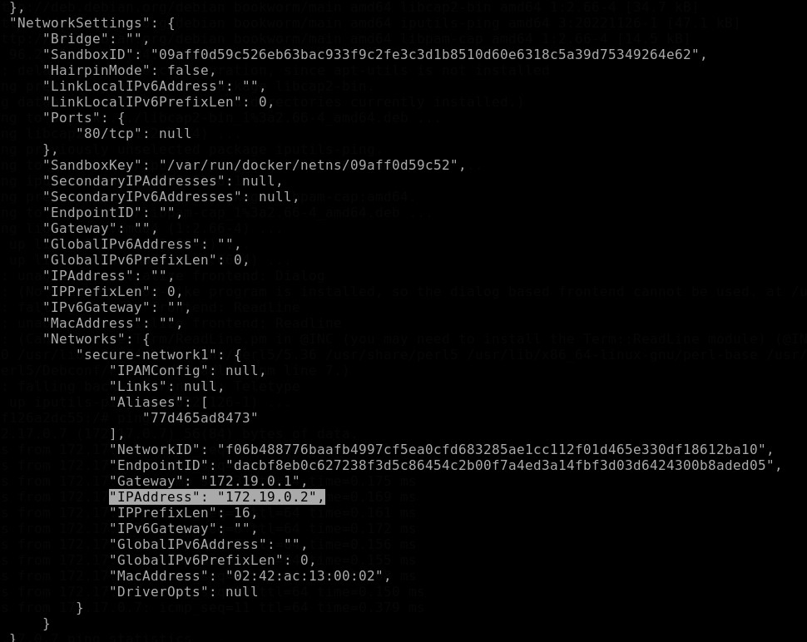

### Step 5:

Now ping IP address of cyber in any one of the containers.

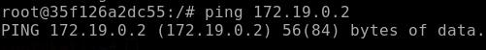

# Conclusion:

Successfully Created a Network in Docker and Connected a Container to that Network.

**Experiment No: 16**

**Sniff And Spoof the Network of Other Operating System Using Bettercap**

# Aim:

To Sniff and Spoof the network of another operating system.

# Objective:

To shut down a machine or network, making it inaccessible to its intended users. By flooding the target with traffic, or sending it information that triggers a crash.

## Hardware/Software Required:

Metasploitable, kali Linux, windows

# Theory:

Better cap is a powerful, easily extensible and portable framework written in Go which aims to offer to security researchers, red teamers and reverse engineers an easy to use, all-in-one solution with all the features they might possibly need for performing reconnaissance and attacking Wi- Fi networks, Bluetooth Low Energy devices, wireless HID devices and Ethernet networks.

MAIN FEAYUTES OF BETTERCAP:

1. WIFI networks scanning, deauthentication attack, clientless PMKID association attack and automatic WPA/WPA2 client handshakes capture.
2. Bluetooth Low Energy devices scanning, characteristics enumeration, reading and writing.
3. 2.4Ghz wireless devices scanning and MouseJacking attacks with over-the-air HID frames injection (with DuckyScript support).
4. Passive and active IP network hosts probing and recon.
5. ARP, DNS, NDP and DHCPv6 spoofers for MITM attacks on IPv4 and IPv6 based networks.
6. Proxies at packet level, TCP level and HTTP/HTTPS application level fully scriptable with easy to implement JavaScript plugins.
7. A powerful network sniffer for credentials harvesting which can also be used as a network protocol fusser.
8. A very fast port scanner.
9. A powerful REST API with support for asynchronous events notification on websocket to orchestrate your attacks easily.
10. A very convenient web UI

# HTTP:

In Bettercap, HTTP is a protocol used for web communication. Bettercap is a powerful network attack and monitoring framework that allows you to perform various network-related tasks, including HTTP protocol analysis and manipulation. You can use Bettercap to intercept and modify HTTP requests and responses, perform man-in-the-middle attacks, or even sniff and analyze HTTP traffic for security testing and troubleshooting purposes.

# Procedure

### Step 1:

The **bettercap -iface eth0** command will launch the BetterCAP network attack framework usingthe "**eth0**" interface for network interaction and various tasks like sniffing, spoofing,and interception.

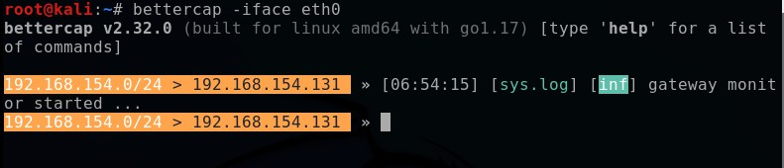

### Step 2:

The **–help** command in BetterCAP is used to display a list of available commands and their descriptions within the BetterCAP command-line interface (CLI).

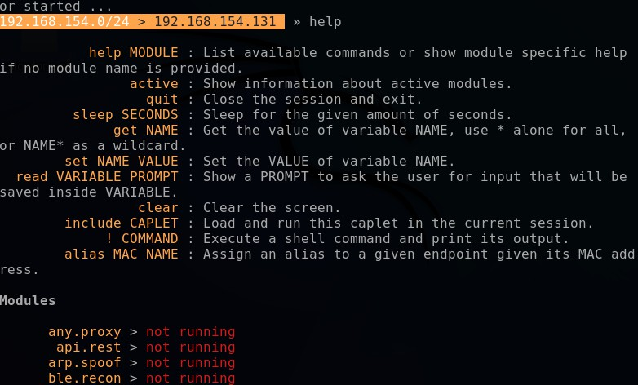

### Step 3:

The **net.probe** module in BetterCAP is used to perform network probing. Network probing involves actively scanning the target network to discover hosts, services, and other valuable information. By using the **"net.probe"** module, you can discover devices, open ports, and potentially identify vulnerabilities in the target network.

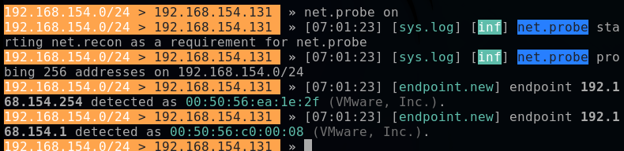

## Step 4:

The **net.show** module in BetterCAP is used to display information about the discovered hosts and services on the network**.**

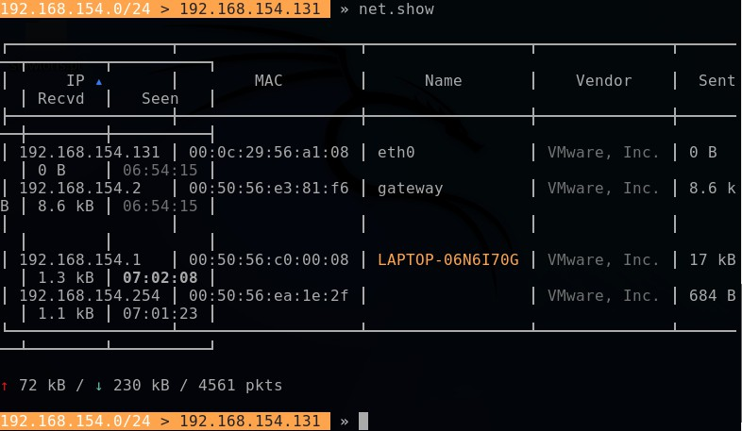

## Step 5:

**set arp.spoof.fullduplex true** command is used to enable full-duplex ARP spoofing in Bttercap.



### Step 6:

**set arp.spoof.target <IP address>** command sets the target for ARP spoofing, meaning that Bttercap will spoof ARP packets to manipulate the target's network traffic.



### Step 7:

The **arp.spoof on** command in Bettercap is used to enable ARP spoofing, which is a technique that allows an attacker to manipulate the Address Resolution Protocol (ARP) tables on devices within a local network.

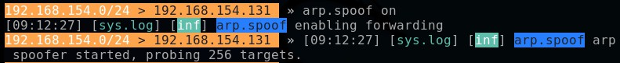

### Step 8:

The **net.sniff on** command in Bettercap is used to enable packet sniffing, which allows the tool to capture and inspect network packets flowing through the network interface.

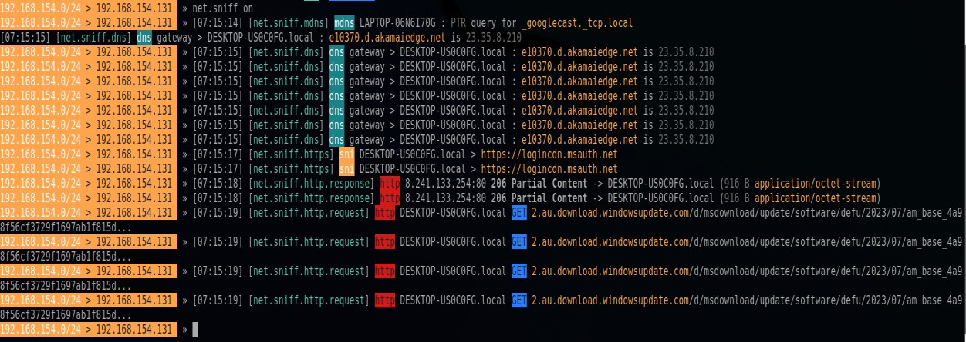

### Step 9:

In windows –search **vulnweb** login

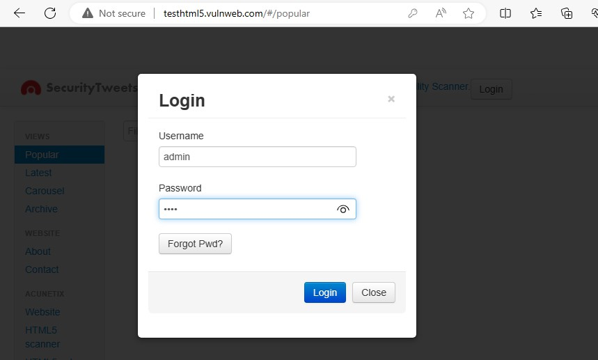

### Step 10:

Then in terminal,it will show login detail such as **username** and **password.**

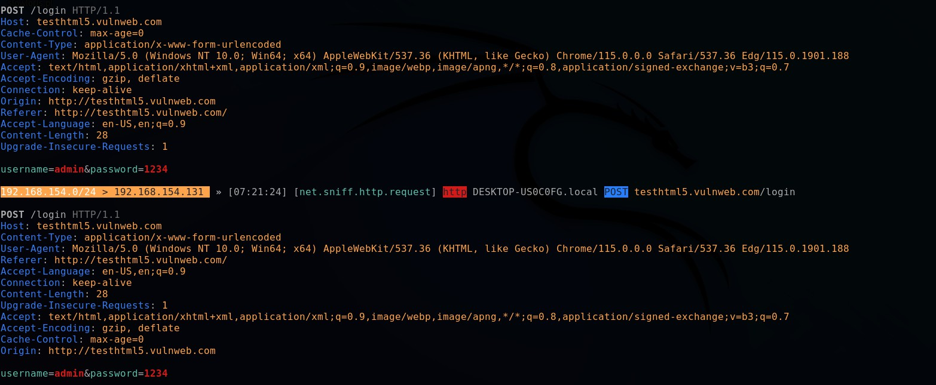

### Step 11:

net.sniff off disables the packet sniffing feature, stopping the capture of network packets.



# HTTPS:

Bettercap supports HTTPS interception and analysis by acting as a man-in-the-middle proxy. This allows it to monitor and intercept HTTPS traffic between clients and servers, helping with security testing and analysis. However, it's essential to use this feature responsibly and with proper authorization, as HTTPS interception can raise privacy and ethical concerns.

# Procedure:

### Step 1:

Create one file <nano cyber.cap> and write a code inside the file

**net.probe on**

**set arp.spoof.fullduplex true**

**set arp.spoof.target<IP address>##windows IP address arp.spoof on**

**set net.sniff.local true net.sniff on**

**Step 2:**

**bettercap -iface eth0 -caplet <file name>** command, you would replace **"<file name>"** with the actual name of your custom caplet file. The caplet file should be written in the Caplet scripting language and contain the instructions and actions you want Bettercap to execute during its operation on the specified network interface **("eth0").**

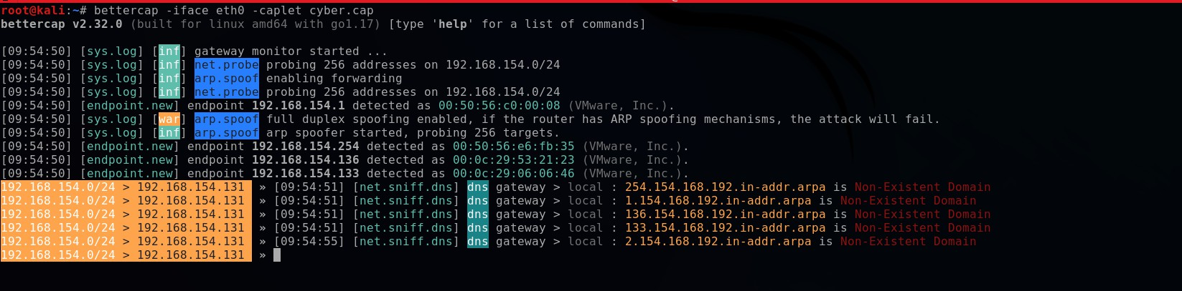

### Step 3:

**caplets.show** command in the Bettercap command-line interface (CLI), you will see a list of available caplets along with their names and descriptions.

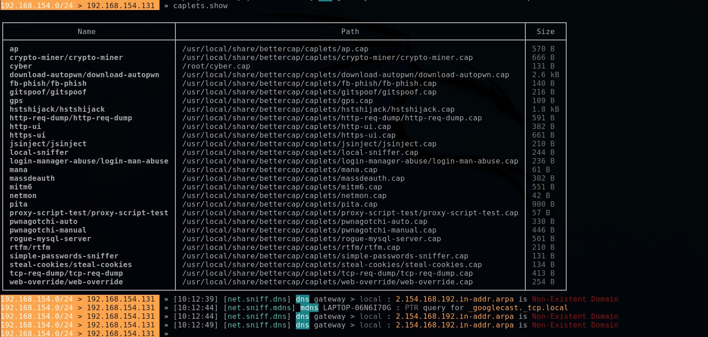

**Step 4:**

**hstshijack/hstshijac**



**Step 5:**

Go to windows search stack overflow and it shows error detection i.e is website can’t reach.

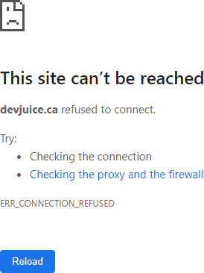

# DNS:

Bettercap has a DNS module that allows you to perform DNS-related operations and manipulations. You can enable the DNS module using the command dns.on. The module provides features for DNS spoofing, DNS cache poisoning, DNS over HTTP (DoH) interception, and DNS over TLS (DoT) interception. DNS spoofing can be enabled using dns.spoof. Keep in mind that DNS manipulations should only be used responsibly with proper authorization for legitimate security assessments. Always follow ethical guidelines and obtain necessary permissions before using any security tools.

# Procedure:

### Step 1:

**bettercap -iface eth0 -caplet <file name>** command, you would replace "<file name>" with the actual name of your custom caplet file. The caplet file should be written in the Caplet scripting language and contain the instructions and actions you want Bettercap to execute during its operation on the specified network interface **("eth0").**

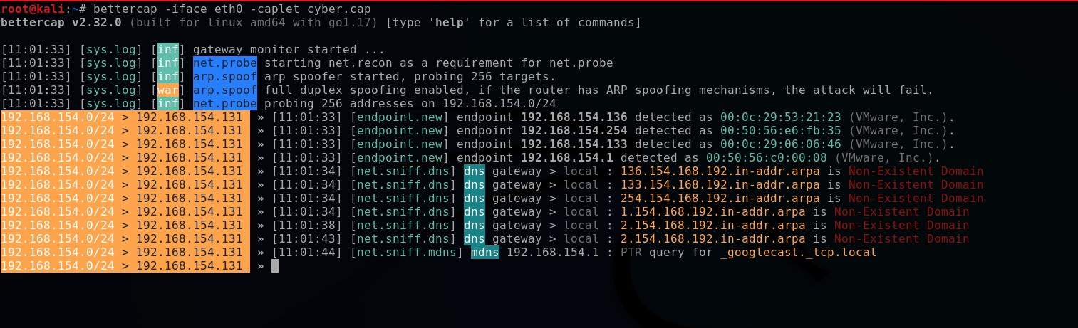

### Step 2:

**set dns.spoof all true** command will enable DNS spoofing for all DNS queries, meaning that Bettercap will respond to any DNS request with the spoofed DNS response. This could lead to redirecting all DNS queries to the IP address you control.

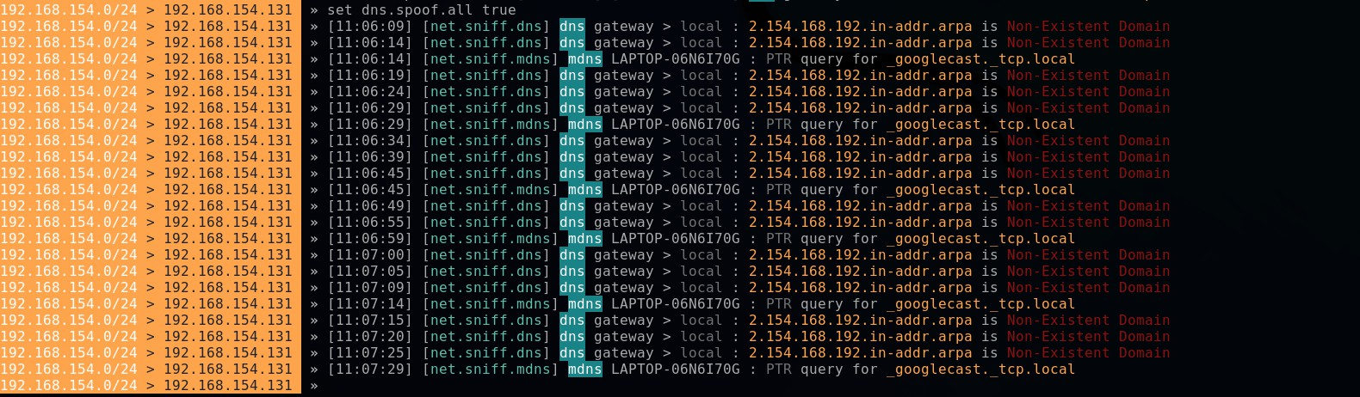

### Step 3:

**set dns.spoof.domains zsecurity.org *.zsecurity.org** command configures Bettercap to enable DNS spoofing for the specified domains. In this case, it sets DNS spoofing for all subdomains of "zsecurity.org" and the main domain itself.

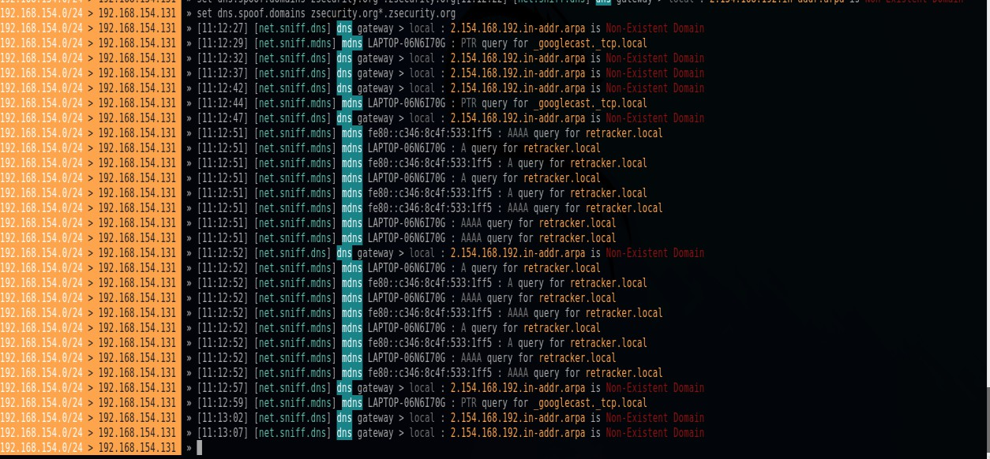

### Step 4:

**dns.spoof on** command in the Bettercap command-line interface (CLI), it enables DNS spoofing. Once enabled, Bettercap will start spoofing DNS responses and redirecting DNS queries to the IP address you have specified for the targeted domains.

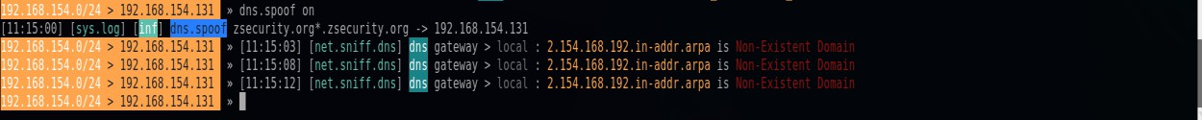

### Step5:

Next, In windows , search zsecurity.org and it shows error detect



### Step6:

**dns.spoof off** command in the Bettercap command-line interface (CLI) will disable DNS spoofing. Once disabled, Bettercap will stop spoofing DNS responses and DNS queries will be handled normally without any redirection.



# Conclusion:

Bettercap is a powerful and comprehensive network attack and monitoring framework that offers a wide range of tools for security assessments and ethical hacking purposes. It provides features like ARP and DNS spoofing, HTTP and HTTPS interception, packet sniffing, and various other functionalities that allow security professionals to identify vulnerabilities and improve network defenses.